
A Reliability-Aware Decision Framework for Cost-Sensitive Selective Prediction in Credit Risk under Distribution Shift

Master Thesis
by
Amin Feli
Matriculation no: 11038701

12-09-2026

SRH University Heidelberg
School of Information, Media and Design
M.Sc. Applied Data Science and Analytics
Supervisors
Prof. Dr. Mehrdad Jalali
Prof. Dr. Binh Vu
Declaration of Authorship

I hereby declare that my herewith submitted thesis titled “A Reliability-Aware Decision Framework for Cost-Sensitive Selective Prediction in Credit Risk under Distribution Shift” is my own original work. I have written it independently without outside help and have not used any sources other than those indicated – in particular, no sources not named in the references.

I have appropriately indicated any direct quotations or passages taken from literature, and the use of intellectual property from other authors, by providing the necessary citations within the work. This applies equally to the sources used for text generation by Artificial Intelligence (AI).

I hereby declare that the thesis was not previously presented to another examination board, and I also confirm that the PDF version of this thesis is exactly identical in content to the hard copy.

Place, Date: Mannheim, 12-09-2026

Signature:
Acknowledgements

First and foremost, I would like to express my sincere gratitude to Prof. Dr. Mehrdad Jalali, my thesis supervisor, for his guidance, support, and valuable feedback throughout the process of conducting and writing this thesis. His expertise, constructive suggestions, and encouragement have been invaluable to the successful completion of this research.
I would also like to express my sincere appreciation to all the professors and lecturers of the M.Sc. Applied Data Science and Analytics program at SRH University Heidelberg for providing me with the knowledge, skills, and academic foundation necessary to undertake this research.
Furthermore, I am deeply grateful to my family and friends for their continuous encouragement, patience, and support throughout my studies and the preparation of this thesis. Their understanding and motivation have been an important source of strength during this challenging period.
Finally, I would like to thank everyone who contributed directly or indirectly to this research and supported me during the completion of this thesis. Their assistance and encouragement are sincerely appreciated.

Abstract
This thesis develops and evaluates an end-to-end machine learning pipeline for credit risk prediction using a dataset of 50,000 loan applications. The study addresses four gaps commonly left open in the applied credit-scoring literature: rigorous, root-cause-driven data cleaning; explicit cost-sensitive decision-threshold optimisation; SHAP-based explainability at both the global and local level; and a quantitative reliability-monitoring and selective prediction framework suitable for production deployment. A tuned XGBoost classifier, trained on an engineered and selected feature set, achieved a test-set AUC of 0.9763 and, at a cost-optimized decision threshold of 0.28, a recall of 97% for the default class with an FP/FN ratio of 5.11. SHAP analysis identified credit score, debt-to-income ratio, credit history length, and loan-to-income ratio as the dominant predictors, with the top ten features explaining approximately 84.6% of the model's decisions. A reliability-monitoring framework based on the Population Stability Index and the Kolmogorov–Smirnov statistic detected no meaningful drift on a simulated production batch. Finally, a two-threshold selective prediction framework, referring 12.3% of applications to manual review, reduced total business cost by approximately 58.5% and false negatives by approximately 58.7% relative to a conventional single-threshold baseline. These results demonstrate that integrating cost-sensitivity, explainability, and reliability monitoring into a single credit-risk pipeline yields substantial, quantifiable improvements over conventional accuracy-driven modeling.

Table of Contents
1. Introduction 1
1.1 Background and Motivation 1
1.2 Problem Statement 2
1.3 Research Gap 2
1.4 Research Objectives 3
1.5 Research Questions 4
1.6 Research Contributions 5
1.7 Thesis Structure 5
2. Related Work 7
2.1 Credit Risk Assessment 7
2.2 Machine Learning for Credit Risk Prediction 7
2.3 Data Quality and Preprocessing in Credit Risk Modeling 8
2.4 Feature Engineering and Feature Selection 8
2.5 Cost-Sensitive Classification 9
2.6 Decision Threshold Optimization 9
2.7 Explainable Artificial Intelligence in Credit Risk 10
2.8 Model Reliability and Distribution Shift 10
2.9 Selective Prediction and Human-in-the-Loop Decision Making 11
3. Technical Background 12
3.1 Credit Risk Prediction as a Binary Classification Problem 12
3.1.1 Loan Default and Binary Classification Formulation 12
3.2 Gradient Boosting (XGBoost) 13
3.2.1 Gradient Boosting 13
3.2.2 Class Weighting 13
3.3 Data Preprocessing and Feature Engineering 14
3.3.1 Data Type Handling & Missing-Value Handling 14
3.3.2 Skewness Analysis and Logarithmic Transformation 16
3.4 Exploratory Data Analysis 17
3.4.1 Descriptive Statistics and Correlation Analysis 17
3.4.2 Multimodality Analysis 18
3.5 Feature Importance and Feature Selection 20
3.5.1 XGBoost Feature Importance 20
3.5.2 Permutation Importance 21
3.5.3 SHAP-Based Feature Importance 21
3.6 Model Evaluation 23
3.6.1 Accuracy, Precision 23
3.7 Cost-Sensitive Decision Making 25
3.7.1 Business Cost Function 25
3.8 Explainable AI with SHAP 26
3.9 Reliability Monitoring and Distribution Shift 27
3.9.1 Concept of Data Drift 27
3.10 Selective Prediction 29
3.10.1 Selective Classification & Decision Zones 29
4. Methodology 30
4.1 Research Design 30
4.2.1 Predictor Variables 31
4.3 Data Quality Assessment and Cleaning 32
4.3.1 Detection of Corrupted Records and Validity Checks 32
4.4 Exploratory Data Analysis 34
4.4.1 Numerical and Categorical Feature Analysis 34
4.4.2 Correlation Analysis 34
4.4.3 Outlier Analysis 36
4.5 Feature Engineering 37
4.5.1 Logarithmic Transformation 37
4.6 Feature Selection 38
4.7 Dataset Partitioning 39
4.7.1 Prevention of Data Leakage 39
4.8 XGBoost Model Development 40
4.9 Cost-Sensitive Threshold Optimization 42
4.9.1 Definition of the Business Cost Function 42
4.10 Model Evaluation 42
4.10.1 Error Analysis 42
4.11 Explainability Analysis 43
4.11.1 SHAP TreeExplainer 43
4.12 Reliability Monitoring Framework 45
4.12.1 Reference Baseline Construction & Prediction Drift Monitoring 45
4.13 Selective Prediction Framework 46
4.13.1 Definition of the Selective Decision Zones 46
4.14 Experimental Workflow 47
5. Experimental Results 49
5.1 Distribution and Skewness Analysis 49
5.2 Feature Selection Results 50
5.2.1 Feature Importance Results 50
5.3 Hyperparameter Optimization Results 52
5.3.1 Comparison of Hyperparameter Configurations 52
5.4 Final XGBoost Model Performance 53
5.4.1 Training, Validation and Test AUC 53
5.5 Explainability Results 56
5.5.1 Global SHAP Feature Importance 56
5.6 Reliability Monitoring Results 59
5.6.1 Feature-Level Drift Results 59
5.7 Selective Prediction Results 60
5.7.1 Optimization of Selective Prediction Thresholds 60
5.8 Comparison of Single-Threshold and Selective Prediction 61
5.8.1 Error Reduction and Cost Reduction 61
5.9 Integrated Reliability and Decision-Making Results 62
6. Discussion 64
6.1 Interpretation of the Main Findings 64
6.3 Importance of Threshold Optimization & Contribution of Explainability 65
6.4 Reliability under Distribution Shift 65
6.5 Comparison with the Research Objectives 66
6.6 Limitations of the Study 67
7. Conclusion and Future Work 68
7.1 Main Contributions 68
7.1.1 Cost-Sensitive Credit Risk Prediction 68
7.2 Key Experimental Findings 69
7.3 Research Questions Revisited 69
7.4 Future Research Directions 70
References 71
Appendix A: Full Dataset Feature Dictionary 74
Appendix B: Business Cost Function and Confusion-Matrix Summary 75

List of Figures
Figure 3.1 — Class distribution of the target variable
Figure 3.2 — Outlier Detection Using IQR
Figure 3.3 — Spearman Correlation Matrix for Feature Relationships
Figure 3.4 — Distribution of Loan Amount Revealing Multimodal Patterns
Figure 3.5 — XGBoost Feature Importance Scores of the Predictor Variables
Figure 3.6 — Global SHAP Feature Importance Based on Mean Absolute Shapley Values
Figure 3.7 — ROC curve for the final XGBoost model on the test set
Figure 4.1 — Spearman correlation heatmap of numerical features
Figure 4.2 – Distributions and histograms of all features
Figure 4.3 – Class distribution of the loan_status target variable
Figure 4.4 – Class distribution of the loan_status target variable
Figure 4.5 — SHAP waterfall plot for a representative false-negative applicant
Figure 4.6 – Implementing Selective Decision Zones
Figures 5.1 — Global Feature Importance Based on Mean Absolute SHAP Values
Figures 5.2 – Hyperparameter grid-search results
Figure 5.3 — Hyperparameter fine-tuning using grid search
Figure 5.4 — Optimal FP and FN selection based on the cost function
Figure 5.5 — Top 15 XGBoost feature importances for the final model
Figure 5.6 — Global SHAP summary (beeswarm) plot of feature importance
Figure 5.7 — Predicted-probability distribution with selective-prediction decision zones

List of Tables
Table 4.1 — Summary of dataset features by category
Table 4.2 — Data-cleaning validation rules and outcomes
Table 4.3 — Hyperparameter search space for the XGBoost grid search
Table 5.1 — Test-set confusion matrix at the cost-optimal threshold
Table 5.3 — Global SHAP feature-importance ranking
Table 5.4 — Reliability-monitoring results: feature-level PSI and KS statistics
Table 5.5 – Comparison of single-threshold and selective prediction results

Abbreviations
AUC | Area Under the (ROC) Curve
CART | Classification and Regression Tree
EDA | Exploratory Data Analysis
FN | False Negative
FP | False Positive
F1 | F1-Score (harmonic mean of precision and recall)
IQR | Interquartile Range
KS | Kolmogorov–Smirnov (statistic)
ML | Machine Learning
MLOps | Machine Learning Operations
PSI | Population Stability Index
RFE | Recursive Feature Elimination
ROC | Receiver Operating Characteristic
SHAP | SHapley Additive exPlanations
SMOTE | Synthetic Minority Over-sampling Technique
TN | True Negative
TP | True Positive
XAI | Explainable Artificial Intelligence
XGBoost | Extreme Gradient Boosting

1. Introduction

1.1 Background and Motivation
Access to credit is one of the central mechanisms through which modern financial systems allocate capital to households and businesses. Banks, credit unions, and other lending institutions must continuously decide whether an applicant for a personal loan, credit card, or line of credit is likely to repay the borrowed amount. This decision, commonly referred to as credit risk assessment, has historically relied on the judgement of loan officers supported by relatively simple scoring rules. Over the past three decades, however, the scale of consumer lending, the availability of digitized financial records, and the competitive pressure to automate decision-making have driven a shift toward statistical and, more recently, machine-learning-based credit scoring systems.
The motivation for the present study stems from the observation that although many machine learning models achieve high predictive accuracy on credit risk datasets, accuracy alone is an incomplete criterion for a system that will be deployed in a real banking environment. A model that predicts loan_status with 95% accuracy may still be commercially unacceptable if the errors it does make are concentrated on the costliest cases, that is, applicants who are incorrectly classified as safe borrowers and subsequently default. Conversely, a model that is overly conservative may reject a large proportion of creditworthy applicants, causing the bank to lose profitable business. This tension between statistical performance and business cost is a recurring theme throughout this thesis.
A second motivation concerns trust and transparency. Regulators, auditors, and loan applicants increasingly expect financial institutions to be able to explain individual credit decisions rather than treating the underlying model as a black box. Explainable artificial intelligence techniques, and in particular SHAP (SHapley Additive exPlanations), provide a principled way of attributing a prediction to the contribution of each input feature, both globally across the portfolio and locally for a single applicant.
A third motivation concerns the fact that a model which performs well at the moment of deployment does not necessarily continue to perform well as time passes. Economic conditions change, the mix of applicants shifts, and the statistical relationship between features and default outcomes can drift. This motivates the design of a reliability monitoring framework capable of detecting data drift, prediction drift, and performance degradation before they translate into financial losses.
Finally, the recognition that some applicants are inherently difficult to classify with confidence motivates the introduction of a selective prediction framework, in which the model is permitted to abstain from an automatic decision and instead refer borderline cases to a human loan officer. Taken
together, these four motivations, predictive performance, cost-sensitivity, explainability, and reliability, define the scope of the present thesis, which develops and evaluates an end-to-end credit risk decision system built around an XGBoost classifier trained on a dataset of 50,000 loan applications.

1.2 Problem Statement
The central problem addressed in this thesis can be stated as follows: given a set of demographic, financial, and credit-history attributes describing a loan applicant, how can a predictive model be designed, trained, and calibrated so that it (i) accurately distinguishes between applicants who will default and applicants who will repay, (ii) explicitly accounts for the asymmetric financial cost of false negatives (approving a defaulting customer) relative to false positives (rejecting a creditworthy customer), (iii) remains interpretable to stakeholders who are not machine learning specialists, and (iv) continues to operate reliably after deployment, even as the characteristics of incoming applicants evolve over time.
Conventional classification pipelines typically optimize a symmetric loss function and apply a fixed decision threshold of 0.5 to the predicted probability of default. This approach ignores the fact that, in a lending context, the financial consequence of a missed default is usually far greater than the consequence of rejecting a good applicant. It also implicitly assumes that every prediction should be resolved automatically, even when the model itself is uncertain, and it provides no mechanism for detecting when the deployed model's assumptions no longer hold. The problem addressed by this thesis is therefore not simply 'build an accurate classifier', but 'build a classification and decision-making pipeline that is accurate, cost-aware, explainable, and monitorable', using the loan application dataset described in Chapter 4 as the empirical setting.

1.3 Research Gap
A review of the credit-scoring literature (elaborated in Chapter 2) reveals that although individual components of the proposed pipeline, gradient boosting classifiers, cost-sensitive threshold selection, SHAP-based explainability, and drift monitoring, have each been studied extensively in isolation, comparatively few studies integrate all of these components into a single, coherent, end-to-end system and evaluate them jointly on the same dataset. Much of the published work on credit scoring focuses narrowly on maximizing discrimination metrics such as AUC or the Gini coefficient, without explicitly modeling the asymmetric business cost of classification errors. Where cost-sensitive methods are discussed, they are frequently limited to class-weighting during training rather than post-hoc threshold optimization informed by an explicit cost function.
Similarly, although SHAP has become a popular explainability tool for tree-based credit models, many studies stop at reporting global feature-importance rankings and do not connect the explainability analysis back to the business decision (for example, by examining SHAP values for the specific applicants that the model misclassifies). Literature on data drift and model monitoring is comparatively mature in the general machine-learning-operations community but is less frequently applied specifically to credit risk, where regulatory expectations for ongoing model validation are particularly stringent. Finally, selective prediction, that is, allowing a classifier to defer uncertain cases to a human reviewer rather than forcing a binary decision, has been explored in the broader pattern-recognition literature but is rarely combined with cost-sensitive threshold optimisation and drift monitoring in a single, unified banking application.
The research gap addressed by this thesis is therefore the absence, in the applied credit-risk literature, of a single empirical study that (a) builds a high-performing gradient-boosting model on a realistic loan-application dataset, (b) rigorously cleans and validates the underlying data, (c) selects features using three complementary importance techniques, (d) optimises the decision threshold against an explicit, asymmetric business cost function, (e) explains the resulting model both globally and locally using SHAP, (f) implements a quantitative reliability-monitoring framework based on the Population Stability Index and the Kolmogorov–Smirnov statistic, and (g) extends the single-threshold decision rule into a three-zone selective prediction framework with automatic approval, automatic rejection, and human review. This thesis fills that gap.

1.4 Research Objectives
The research objectives pursued in this thesis are:
To design and implement a rigorous data-cleaning and validation pipeline for a large (50,000-record) loan-application dataset, capable of detecting corrupted, logically inconsistent, or out-of-range records.
To conduct a thorough exploratory data analysis of the cleaned dataset, characterizing the distribution, skewness, correlation structure, and class balance of the available features.
To engineer and select a compact, informative feature set using logarithmic transformation, standardization, categorical encoding, and three feature-selection techniques (XGBoost importance, permutation importance, and SHAP).
To train and hyper-parameter-tune an XGBoost classifier for the binary prediction of loan default, using class weighting to address the observed class imbalance.
To design and optimize a cost-sensitive decision threshold that explicitly minimizes a business cost function reflecting the asymmetric cost of false negatives and false positives.
To explain the resulting model using SHAP, at both the global (portfolio) and local (individual applicant) level.
To design and evaluate a quantitative reliability-monitoring framework capable of detecting data drift, prediction drift, and performance degradation in production.
To design and evaluate a selective prediction framework that introduces a manual-review zone between automatic approval and automatic rejection, and to quantify its benefit relative to a conventional single-threshold classifier.

1.5 Research Questions
The following research questions guide the empirical work reported in Chapters 4 and 5:
RQ1: How does systematic data cleaning and validation affect the quality and reliability of a large loan-application dataset, and what proportion of records are affected by corrupted or inconsistent values?
RQ2: Which applicant features are most strongly associated with loan default, and do the rankings produced by correlation analysis, XGBoost importance, permutation importance, and SHAP agree with one another?
RQ3: To what extent does an XGBoost classifier, trained on the engineered feature set, achieve strong discrimination (AUC) and classification performance (accuracy, precision, recall, F1) on held-out validation and test data?
RQ4: How does optimising the classification threshold against an explicit business cost function change the trade-off between false positives and false negatives relative to the default 0.5 threshold?
RQ5: What do global and local SHAP explanations reveal about the drivers of the model's predictions, and how do these explanations align with domain knowledge about credit risk?
RQ6: Can a quantitative monitoring framework based on the Population Stability Index, the Kolmogorov–Smirnov statistic, and ongoing performance tracking reliably detect the presence or absence of data drift, prediction drift, and performance degradation?
RQ7: Does a selective prediction framework, in which uncertain applicants are referred to manual review, reduce the business cost and the number of false negatives relative to a single-threshold decision rule, and what proportion of applicants can be handled automatically?

1.6 Research Contributions
This thesis makes the following contributions to the applied credit-risk and machine-learning literature. First, it presents a detailed, reproducible data-cleaning methodology for loan-application data that explicitly distinguishes between genuine data corruption and artifacts introduced by inconsistent unit scaling, an issue that, if left undiagnoed, can lead a researcher to discard the majority of an otherwise usable dataset. Second, it presents a comparative feature-selection study using three independent importance techniques on the same feature set, allowing convergent and divergent findings to be identified and discussed. Third, it presents a fully worked example of cost-sensitive threshold optimization for a credit-scoring model, including the explicit definition of a business cost function and a systematic search over candidate thresholds. Fourth, it presents a SHAP-based explainability analysis that goes beyond global feature ranking to examine local explanations for individual, including misclassified, applicants. Fifth, it presents a lightweight but quantitatively grounded reliability-monitoring framework suitable for ongoing production use, combining the Population Stability Index and the Kolmogorov–Smirnov statistic for feature-level and prediction-level drift detection with direct performance tracking against a held-out labelled sample. Sixth, and most novel, it presents a selective prediction framework that extends the conventional single-threshold decision rule into a three-zone system (automatic approval, manual review, automatic rejection), and empirically quantifies the reduction in business cost and false negatives that this framework achieves relative to the conventional approach. Collectively, these contributions provide a template that other researchers and practitioners can adapt when building end-to-end, business-aware credit risk decision systems.

1.7 Thesis Structure
The remainder of this thesis is organized as follows. Chapter 2 reviews the related work in credit risk assessment, machine learning for credit scoring, data quality and preprocessing, feature engineering and selection, cost-sensitive classification, threshold optimization, explainable artificial intelligence, model reliability and distribution shift, and selective prediction, before positioning the present study relative to this literature. Chapter 3 introduces the technical background required to understand the methodology, covering binary classification, gradient boosting and XGBoost, data preprocessing techniques, exploratory data analysis methods, feature importance techniques, evaluation metrics, cost-sensitive decision making, SHAP-based explainability, reliability monitoring, and selective prediction. Chapter 4 describes the methodology applied in this study in detail, including the dataset, the data-cleaning pipeline, exploratory analysis, feature engineering and selection, model development, threshold optimization, explainability analysis, reliability monitoring, and the selective prediction framework. Chapter 5 reports the experimental results obtained at each stage of the pipeline. Chapter 6 discusses the findings in light of the research questions and objectives, and considers the practical implications and limitations of the study. Chapter 7 concludes the thesis, summarizing the contributions, revisiting the research questions, and proposing directions for future research.

2. Related Work

2.1 Credit Risk Assessment
Credit risk assessment is the process by which a lender estimates the likelihood that a borrower will fail to meet the contractual obligations of a loan. Traditionally, credit risk was assessed through expert judgment, in which experienced loan officers evaluated an applicant's character, capacity, capital, collateral, and prevailing economic conditions, the so-called 'five Cs of credit'. As consumer lending grew in scale during the second half of the twentieth century, statistical scoring systems, most notably the FICO score in the United States, were introduced to standardize and automate this judgment, using logistic regression models fitted to historical repayment data. [17][25].
The literature identifies several recurring themes in credit risk assessment research: the choice of predictive features (demographic, behavioural, and transactional), the treatment of censored and imbalanced outcome data, the trade-off between model interpretability and predictive power, and the increasing regulatory scrutiny applied to automated credit decisions under frameworks such as the Equal Credit Opportunity Act and, in the European context, the General Data Protection Regulation's provisions on automated decision-making. The dataset used in this thesis, comprising demographic, financial, credit-history, and loan-specific attributes together with engineered financial ratios, is representative of the feature categories commonly used in this literature. [20][7][1].

2.2 Machine Learning for Credit Risk Prediction
Since the early 2000s, the credit-scoring literature has progressively adopted machine learning methods, including decision trees, random forests, support vector machines, and, more recently, gradient boosting frameworks such as XGBoost, LightGBM, and CatBoost, as alternatives to logistic regression. Empirical comparisons generally find that gradient boosting methods achieve equal or superior discrimination performance (commonly measured by the area under the receiver operating characteristic curve) relative to logistic regression, particularly when the relationship between features and the target is non-linear or involves complex interactions among variables such as income, debt, and credit history. [4][20][26].
Neural network architectures, including feed-forward networks and, for datasets containing sequential or transactional information, recurrent architectures, have also been applied to credit scoring, though their advantage over gradient boosting on structured, tabular data of the kind used in this thesis is less consistently observed. A recurring finding across this literature is that tree-based ensemble methods offer an attractive balance of predictive performance, computational efficiency, robustness to outliers and unscaled features, and, through techniques such as SHAP, a reasonable degree of interpretability, which motivates the choice of XGBoost as the primary model in this thesis. [24][14].

2.3 Data Quality and Preprocessing in Credit Risk Modeling
Data quality is widely recognized in the applied machine learning literature as a first-order determinant of model performance, often exceeding the marginal benefit obtained from algorithmic sophistication. In the credit-scoring domain specifically, prior work has documented the prevalence of missing values arising from incomplete applications, inconsistent encoding of categorical variables (for example, differing capitalisation or terminology for employment status), illogical or out-of-range values arising from data entry error, and, less commonly discussed but empirically important, inconsistencies in the scale or units used to record derived variables such as financial ratios. [15].
This thesis contributes to this literature by documenting a case in which a naive range-validation rule applied to financial ratio variables flagged the overwhelming majority of records (48,901 out of 50,000) as invalid, not because the underlying data were corrupted, but because the ratios had been stored on an inconsistent scale. This finding echoes cautionary observations elsewhere in the literature that automated data-quality rules must be applied with an understanding of how each variable was constructed, since a superficially reasonable validation rule can produce misleading conclusions if the scale or units of a variable are not verified first. [15][23].

2.4 Feature Engineering and Feature Selection
Feature engineering in credit scoring typically involves the construction of ratio variables (such as debt-to-income, loan-to-income, and payment-to-income ratios) that are believed, on the basis of domain knowledge, to summarize an applicant's financial capacity more effectively than the underlying raw variables considered individually. The literature also documents the routine use of logarithmic or Box–Cox transformations to reduce the skewness commonly observed in monetary variables such as income, debt, and loan amount, and the use of standardization or min–max scaling prior to training scale-sensitive algorithms. [19].
Feature selection techniques applied in the credit-scoring literature range from simple filter methods, such as correlation analysis and variance thresholding, through wrapper methods, such as recursive feature elimination, to embedded and post-hoc methods, such as tree-based importance scores, permutation importance, and, increasingly, SHAP-based importance. A recurring finding is that these methods often agree on a core set of highly informative features (typically credit history and debt-related variables) while disagreeing on the ranking of secondary features, a pattern that is also observed in the present study. [16][21].

2.5 Cost-Sensitive Classification
Cost-sensitive classification addresses the observation that, in many real-world applications, the cost of different types of classification error is not symmetric. In credit risk specifically, the cost of a false negative (approving an applicant who subsequently defaults) is typically substantially higher than the cost of a false positive (rejecting an applicant who would have repaid), because a default can result in the loss of the entire outstanding principal, whereas a rejected good applicant represents only a foregone profit margin. The literature proposes several strategies for incorporating this asymmetry into model training and deployment, including class weighting during training, cost-sensitive loss functions, and post-hoc adjustment of the decision threshold applied to predicted probabilities. [9][2].
This thesis adopts a combination of these strategies: class weighting is used during XGBoost training to address the moderate class imbalance observed in the dataset (an imbalance ratio of approximately 1.22), and a separate, explicit business cost function is subsequently used to select the operating decision threshold, following the threshold-search approach discussed further in Section 2.6. [3][18].

2.6 Decision Threshold Optimization
A binary classifier such as XGBoost produces a continuous predicted probability of the positive class, which must be converted into a discrete decision through comparison with a threshold. The conventional default of 0.5 implicitly assumes that false positives and false negatives are equally costly and that the two classes are balanced, assumptions that rarely hold in credit risk applications. The literature on threshold optimization proposes several alternative criteria, including maximizing the F1-score, maximising Youden's J statistic (sensitivity plus specificity minus one), and, most relevant to this thesis, minimizing an explicit expected cost function that assigns different weights to false positives and false negatives. [27][11].
Threshold optimization is typically performed by evaluating the chosen criterion across a fine grid of candidate thresholds on a held-out validation set and selecting the threshold that minimizes the criterion. This thesis follows this established approach, searching over a grid of candidate thresholds and selecting the threshold that minimizes the total weighted business cost, rather than optimizing a purely statistical criterion such as F1. [9][11].

2.7 Explainable Artificial Intelligence in Credit Risk
The adoption of complex, non-linear machine learning models in credit scoring has been accompanied by growing demand, from regulators, auditors, and applicants alike, for these models to be explainable. Explainability techniques applied in the credit-scoring literature include model-intrinsic approaches (such as the coefficients of a logistic regression model or the split-based importance of a decision tree), surrogate modelling (fitting an interpretable model to approximate a complex one), and, increasingly, SHAP, which is grounded in cooperative game theory and provides an additive attribution of each feature's contribution to an individual prediction, consistent with a well-defined set of theoretical properties (local accuracy, missingness, and consistency). [8][21].
SHAP has become particularly popular for tree-based ensemble models such as XGBoost because the TreeExplainer algorithm computes exact Shapley values efficiently, without the approximation required for general model classes. This thesis applies SHAP both globally, to rank the overall contribution of each feature across the portfolio, and locally, to explain individual predictions, including a comparison of SHAP explanations for correctly and incorrectly classified applicants. [22].

2.8 Model Reliability and Distribution Shift
A model that performs well on the data available at training time is not guaranteed to continue performing well once deployed, because the statistical relationship between features and the target, or the distribution of the features themselves, may change over time, a phenomenon generically referred to as distribution shift or drift. The machine-learning-operations literature distinguishes between covariate (feature) drift, label drift, and concept drift, and proposes a range of statistical techniques for detecting each, including the Population Stability Index (PSI), commonly used in the credit-scoring industry to monitor whether the distribution of a scored population has shifted relative to a reference population, and the Kolmogorov–Smirnov (KS) statistic, which quantifies the maximum distance between two empirical cumulative distribution functions. [12][23].
Although PSI and KS are well established in industry practice, particularly in credit risk model validation guidelines issued by banking regulators, they are comparatively underrepresented in academic machine-learning publications relative to more general drift-detection algorithms developed in the streaming-data literature. This thesis applies PSI and KS to monitor both feature-level and prediction-level drift, and supplements these with direct tracking of performance metrics (AUC, confusion matrix, and cost) on newly available labelled data, providing a monitoring framework that is simple to implement yet grounded in established industry practice. [23][12].

2.9 Selective Prediction and Human-in-the-Loop Decision Making
Selective prediction, also referred to as classification with a reject option or learning to defer, allows a classifier to abstain from making a decision when its confidence is low, deferring the case to an alternative decision maker, typically a human expert. The theoretical foundations of this approach date to early work on the reject option in pattern recognition, and it has since been applied in domains including medical diagnosis, fraud detection, and, less commonly, credit risk. The central design choice in a selective prediction system is the definition of the rejection region, that is, the range of predicted probabilities for which the model defers rather than decides automatically. [5][6][13].
In credit risk specifically, selective prediction offers a natural fit with existing bank operations, which already employ human loan officers to review complex or high-value applications. This thesis contributes to this literature by combining selective prediction with the same explicit business cost function used for single-threshold optimization, defining two thresholds (a lower acceptance threshold and an upper rejection threshold) that jointly minimize cost subject to a constraint on the proportion of applications referred for manual review, and by empirically quantifying the resulting reduction in cost and false negatives relative to the single-threshold baseline. [6].
Building on the review presented in Sections 2.1 to 2.9, this section summarizes how the present study is positioned relative to the existing literature. While the individual techniques employed in this thesis, gradient boosting classification, cost-sensitive threshold search, SHAP explainability, PSI/KS-based drift monitoring, and selective prediction, are each established in isolation, this thesis integrates them into a single pipeline applied consistently to one dataset, allowing the interactions between these components to be studied jointly rather than in separate, disconnected studies. In particular, this thesis traces a single decision threshold, first optimised against a business cost function under the single-threshold framework, and then generalised into a two-threshold selective prediction framework, allowing a direct, like-for-like comparison of the two approaches on the same test data, a comparison that is uncommon in the reviewed literature. This positioning defines the specific contribution of the present study relative to prior work and motivates the methodological choices described in Chapter 4. [20][6].

3. Technical Background

3.1 Credit Risk Prediction as a Binary Classification Problem

3.1.1 Loan Default and Binary Classification Formulation
In this thesis, credit risk is operationalied through the binary target variable loan_status, where a value of 1 denotes an outcome associated with elevated risk (default or rejection, depending on the labeling convention adopted for the dataset) and a value of 0 denotes a safe outcome. Loan default occurs when a borrower fails to meet the scheduled repayment obligations of a loan for a sustained period, typically resulting in a write-off or collections process. Predicting this outcome ahead of time, at the point of application, is the fundamental task addressed by the model developed in this thesis. [2].
Formally, given a feature vector x_i describing applicant i, the task is to learn a function f(x_i) that outputs an estimated probability p_i of default, p_i = P(loan_status_i = 1 | x_i). A classification rule then converts this probability into a discrete decision y_hat_i by comparing p_i to a threshold t: y_hat_i = 1 if p_i >= t, else 0. The model is trained by minimising a loss function, typically the binary cross-entropy (log-loss), over a labelled training set, subject to the regularisation and boosting mechanics described in Section 3.2.
Given the binary decision rule above, four outcomes are possible for each applicant: a true negative (correctly approved), a true positive (correctly rejected as high risk), a false positive (a creditworthy applicant incorrectly rejected), and a false negative (a high-risk applicant incorrectly approved). As discussed in Section 2.5, these two error types carry different financial consequences: a false negative exposes the bank to the loss of principal and interest on a defaulted loan, while a false positive represents a foregone profit opportunity. This asymmetry is central to the cost-sensitive methodology developed in Chapter 4.

3.2 Gradient Boosting (XGBoost)

3.2.1 Gradient Boosting
Gradient boosting is an ensemble learning technique that builds a strong predictive model by combining a sequence of weak learners, typically shallow decision trees, in an additive, stage-wise manner. At each boosting iteration, a new weak learner is fitted to the negative gradient (the pseudo-residuals) of the loss function with respect to the current ensemble's predictions, so that each successive tree focuses on correcting the errors of the trees that precede it. The final prediction is a weighted sum of the outputs of all trees in the ensemble. [4].
The weak learners used in gradient boosting are typically Classification and Regression Trees (CART), which partition the feature space recursively by selecting, at each internal node, the feature and split point that most reduces an impurity measure such as the Gini index or, in the boosting context, the second-order approximation of the loss function. Each leaf of the tree is assigned a numeric output value. Decision trees are attractive as base learners because they can capture non-linear relationships and interactions between features without requiring explicit feature engineering of interaction terms.
XGBoost (Extreme Gradient Boosting) is a scalable, regularized implementation of gradient boosting that incorporates a second-order Taylor expansion of the loss function, an explicit regularisation term penalizing tree complexity (the number of leaves and the magnitude of leaf weights), and system-level optimizations such as sparsity-aware split finding and parallelised tree construction. Key hyper-parameters relevant to this thesis include the learning rate (eta), the maximum tree depth, the minimum child weight, the subsample and colsample_bytree ratios, the number of boosting rounds, and the L1/L2 regularisation coefficients (alpha and lambda), all of which are tuned in the hyper-parameter search described in Chapter 4. [4][14].

3.2.2 Class Weighting
Because the dataset used in this thesis exhibits a moderate class imbalance (approximately 55% approved versus 45% rejected, an imbalance ratio of 1.22), class weighting is applied during training via the scale_pos_weight parameter (or equivalent per-sample weights), which increases the penalty associated with misclassifying the minority class. This encourages the boosting algorithm to allocate more of its fitting capacity toward correctly discriminating the minority class, without discarding data (as undersampling would) or introducing synthetic observations (as SMOTE-based oversampling would). [18][3][2].
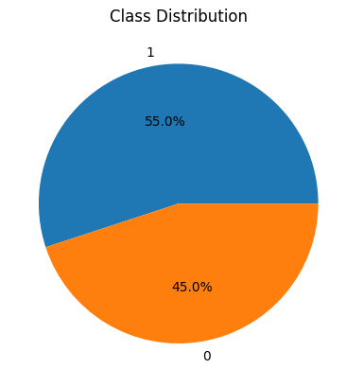

Figure 3.1 — Class distribution of the target variable

3.3 Data Preprocessing and Feature Engineering

3.3.1 Data Type Handling & Missing-Value Handling
Correct data typing ensures that numerical columns intended to represent integer counts (such as age, defaults_on_file, delinquencies_last_2yrs, derogatory_marks, and the binary target loan_status) are stored as integers rather than floating-point numbers, both to reduce memory consumption and to prevent spurious fractional values from appearing in downstream analysis or visualisation.
Missing-value handling encompasses the detection of null or NaN entries (for example via isna().sum()), the choice of an appropriate imputation strategy where missing values are present (mean, median, mode, or model-based imputation), and, where imputation is not appropriate, the removal of affected rows via dropna(). In the dataset used in this thesis, this analysis confirmed the complete absence of missing values across all columns, obviating the need for imputation.
Duplicate detection identifies rows that are exact copies of one another, using the duplicated() function, which can indicate accidental double-counting of an application or a data-export error. Duplicate rows, if present, are typically removed prior to analysis, since retaining them would give the affected observation disproportionate influence during model training.
Business-rule validation applies domain-specific constraints to each variable, for example that age must fall within a plausible adult range, that credit_score must lie within the conventional 300 to 850 range, that monetary variables must be non-negative, and that the three financial ratio variables must fall within a bounded, interpretable range. As discussed in Section 4.3, careful application of this technique is essential, since an incorrectly specified rule (for example, one that assumes a percentage scale for a ratio that was in fact stored on a different scale) can generate a very large number of false positives.
The interquartile range (IQR) method identifies outliers as observations falling below Q1 minus k times the IQR or above Q3 plus k times the IQR, where Q1 and Q3 are the first and third quartiles and k is a multiplier, conventionally 1.5 for 'mild' outliers and 3.0 for 'extreme' outliers. This thesis applies both thresholds to characterize the prevalence of outliers in each numerical feature, as reported in Section 5.1.2.
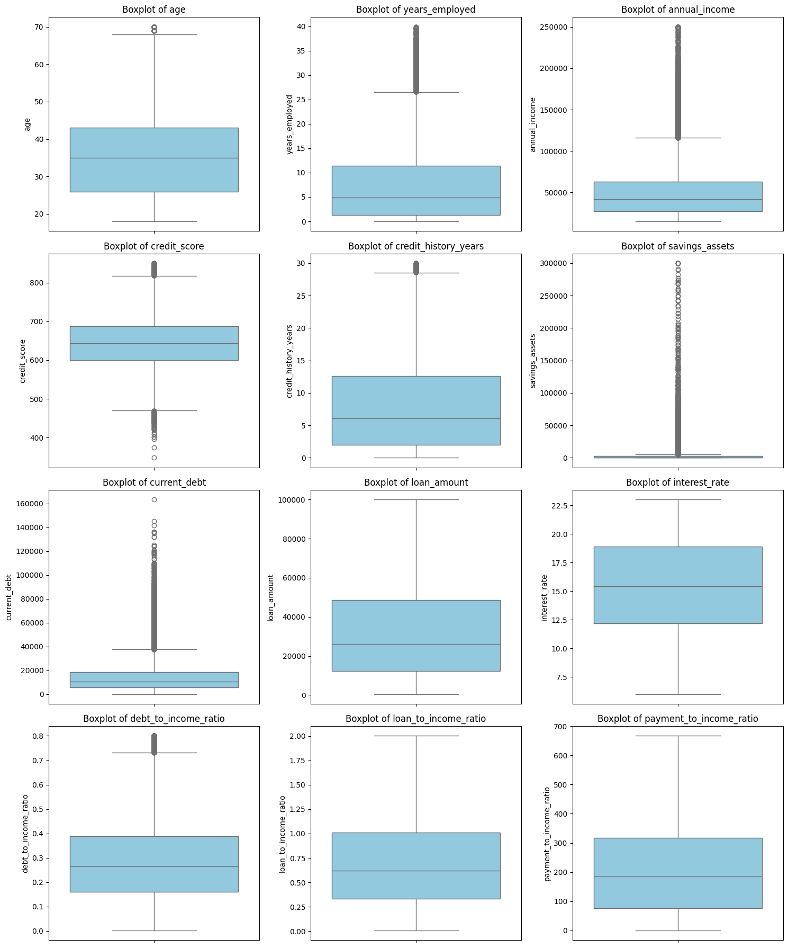
Figure 3.2 — Outlier Detection Using IQR

3.3.2 Skewness Analysis and Logarithmic Transformation
Skewness quantifies the asymmetry of a distribution; monetary variables such as income, debt, savings, and loan amount are typically right-skewed, with a long tail of high values. The logarithmic transformation, commonly implemented as log1p(x) = ln(1+x) to accommodate zero values, compresses this long tail, producing a distribution that is closer to symmetric and therefore more suitable for algorithms and diagnostic techniques that assume approximately normal or homoscedastic residuals.
Feature scaling standardises continuous variables to a common numerical range, most commonly via the StandardScaler, which subtracts the mean and divides by the standard deviation so that each feature has zero mean and unit variance. Although tree-based models such as XGBoost are largely invariant to monotonic feature scaling, standardisation is nonetheless applied in this thesis to support downstream diagnostic analyses (such as modality inspection) and to maintain compatibility with the broader preprocessing pipeline.
Categorical variables such as occupation_status, product_type, and loan_intent are converted into numerical form suitable for model training, typically via one-hot encoding, which creates a binary indicator column for each category. Count variables that are conceptually binary in effect, such as derogatory_marks and delinquencies_last_2yrs, are additionally represented as explicit binary indicators (zero versus one-or-more) to capture the qualitative distinction between having any adverse record at all and having none, in addition to the original count.

3.4 Exploratory Data Analysis

3.4.1 Descriptive Statistics and Correlation Analysis
Descriptive statistics, computed via the describe() function, summarise the central tendency (mean, median) and dispersion (standard deviation, interquartile range, minimum, and maximum) of each numerical feature, providing an initial characterisation of the dataset's scale and variability before any modelling is undertaken.
Visualising the distribution of each feature, typically via histograms with an overlaid kernel density estimate, allows the analyst to identify skewness, modality (the number of peaks), and the presence of outliers or gaps in the data, informing the choice of subsequent transformations.
Correlation analysis quantifies the strength and direction of the linear (Pearson) or monotonic (Spearman) association between pairs of numerical variables. In this thesis, Spearman correlation is preferred for its robustness to skewed distributions and mild outliers, both of which are present in the raw financial variables prior to transformation. Correlation with the target variable provides an initial, univariate indication of feature relevance, while correlation among predictor variables highlights potential multicollinearity.
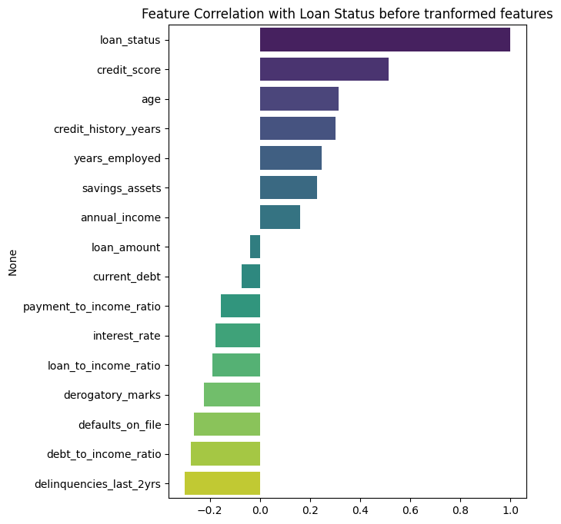
Figure 3.3 — Spearman Correlation Matrix for Feature Relationships
The class distribution of the target variable is examined via a simple frequency count and the derived imbalance ratio (the ratio of the majority to the minority class count). An imbalance ratio close to 1.0 indicates a balanced dataset; ratios beyond approximately 1.5 to 2.0 are often considered to warrant explicit imbalance-handling techniques such as class weighting or resampling.

3.4.2 Multimodality Analysis
Multimodality analysis examines whether a feature's distribution exhibits a single dominant peak (unimodal) or multiple distinct peaks (multimodal), the latter often indicating the presence of underlying subpopulations. In this thesis, this analysis revealed that the loan_amount variable retained a multimodal structure even after logarithmic transformation and standardization, motivating its subsequent categorisation into discrete loan-size groups, as discussed in Section 4.5.
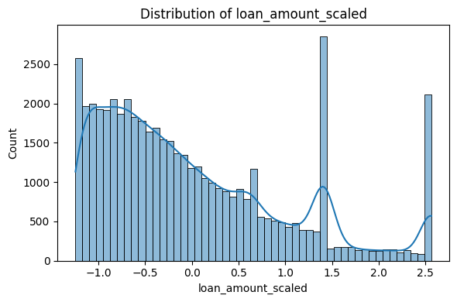
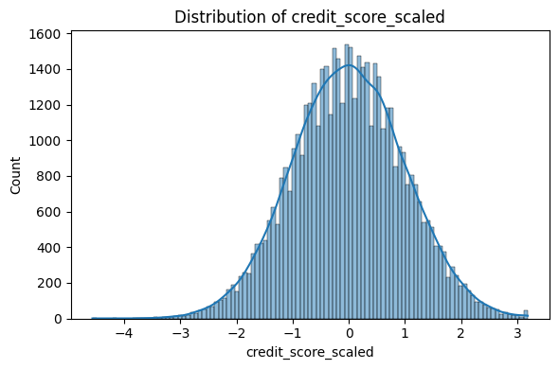

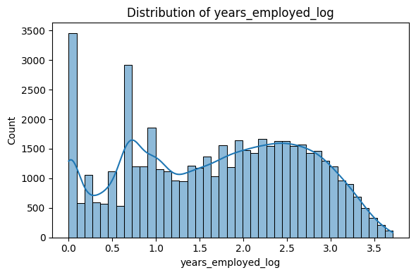
Figure 3.4 — Distribution of Loan Amount Revealing Multimodal Patterns

3.5 Feature Importance and Feature Selection

3.5.1 XGBoost Feature Importance
XGBoost provides built-in feature-importance scores derived from the training process itself, most commonly the 'gain' metric, which measures the average improvement in the loss function attributable to splits on a given feature across all trees in the ensemble, and the 'weight' (or 'frequency') metric, which counts how often a feature is used to split. Gain-based importance is generally preferred as it more directly reflects a feature's contribution to predictive performance rather than merely its frequency of use. [4].
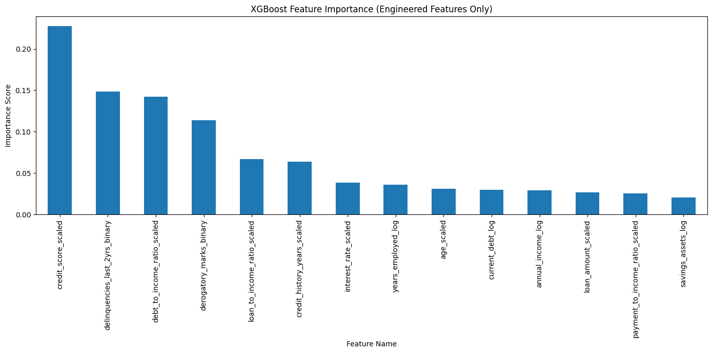
Figure 3.5 — XGBoost Feature Importance Scores of the Predictor Variables

3.5.2 Permutation Importance
Permutation importance is a model-agnostic technique that estimates the importance of a feature by randomly shuffling its values in the validation set and measuring the resulting degradation in model performance (for example, the drop in AUC). A large performance drop indicates that the model relies heavily on that feature; a negligible drop indicates that the feature contributes little unique predictive information once other features are accounted for. Because it is computed on held-out data using the trained model directly, permutation importance is less susceptible than training-based importance metrics to overstating the value of high-cardinality or spuriously informative features.

3.5.3 SHAP-Based Feature Importance
SHAP (SHapley Additive exPlanations) importance derives from cooperative game theory, treating each feature as a 'player' contributing to the 'payout' represented by the difference between an individual prediction and the average prediction across the dataset. For tree ensembles, the TreeExplainer algorithm computes exact Shapley values efficiently. Global SHAP importance is obtained by averaging the absolute Shapley value of each feature across all observations, while local SHAP values explain individual predictions. SHAP importance is generally regarded as the most theoretically grounded of the three feature-importance techniques applied in this thesis, since it satisfies well-defined axioms of fairness (efficiency, symmetry, dummy, and additivity) that neither gain-based nor permutation importance guarantee. [21][22].

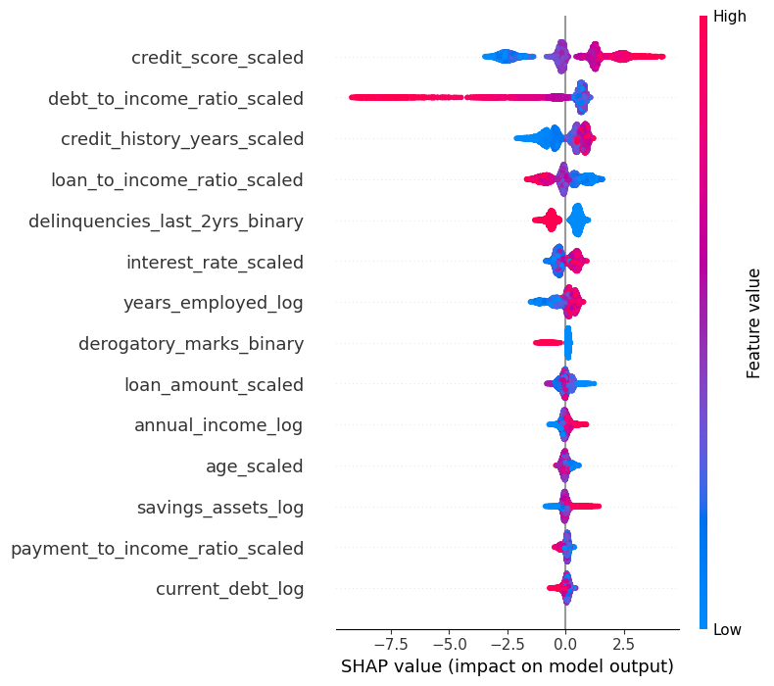

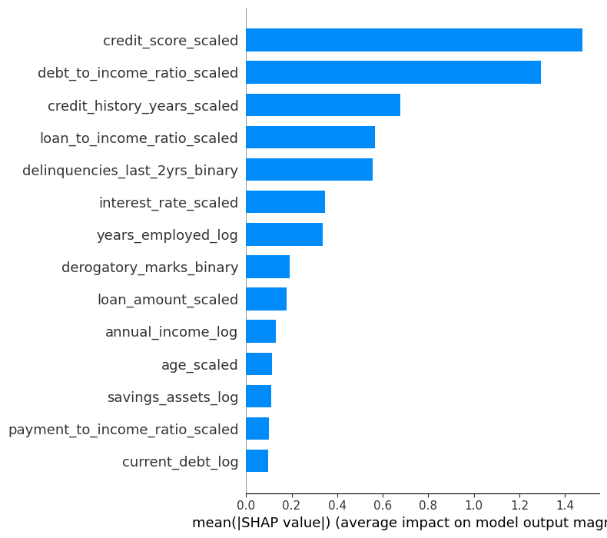
Figure 3.6 — Global SHAP Feature Importance Based on Mean Absolute Shapley Values

3.6 Model Evaluation

3.6.1 Accuracy, Precision
The confusion matrix cross-tabulates predicted against actual class labels, yielding the counts of true negatives, false positives, false negatives, and true positives. It is the foundation from which all of the classification metrics discussed below, as well as the business cost function introduced in Section 3.7, are derived.
Accuracy is the proportion of all predictions that are correct. Precision is the proportion of predicted-positive cases that are truly positive (TP / (TP+FP)), reflecting the reliability of a positive prediction. Recall (sensitivity) is the proportion of truly positive cases that are correctly identified (TP / (TP+FN)), reflecting the model's ability to detect the condition of interest, in this case, default. The F1-score is the harmonic mean of precision and recall, providing a single balanced summary metric that is particularly informative under class imbalance. [27].
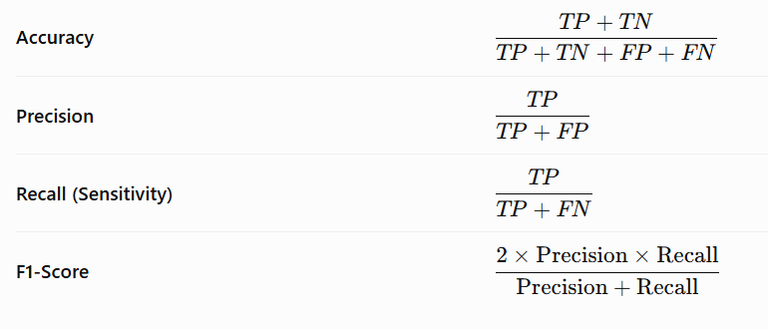

The Receiver Operating Characteristic (ROC) curve plots the true positive rate (recall) against the false positive rate across the full range of possible classification thresholds, illustrating the trade-off between sensitivity and specificity independently of any single threshold choice. The area under this curve (AUC) summarizes the model's overall discrimination ability, with 0.5 corresponding to random guessing and 1.0 corresponding to perfect discrimination; values above 0.9 are generally considered excellent.

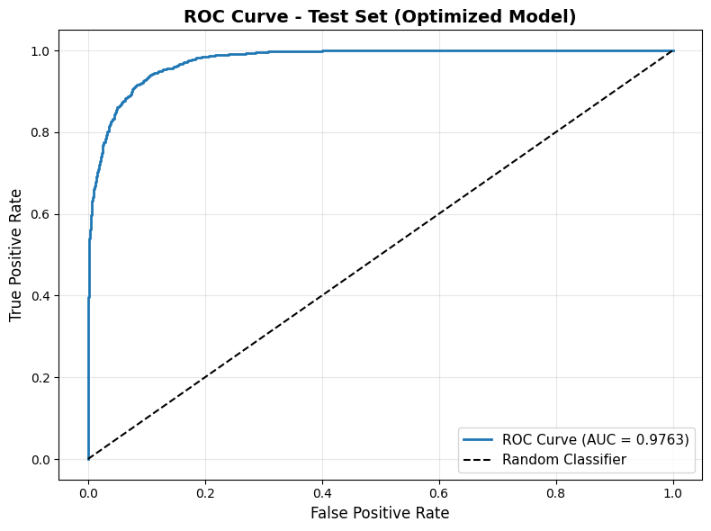

Figure 3.7 — ROC curve for the final XGBoost model on the test set
Beyond aggregate metrics, this thesis places particular emphasis on the disaggregated counts of false positives and false negatives, and their ratio, because these two error types carry different financial consequences in the credit-risk setting, as discussed in Sections 2.5 and 3.1.3. Tracking the FP/FN ratio alongside the confusion matrix allows the analyst to assess directly whether the model's error profile is aligned with the bank's risk appetite.

3.7 Cost-Sensitive Decision Making

3.7.1 Business Cost Function
A business cost function assigns an explicit monetary or relative-unit penalty to each type of classification outcome, typically zero for true positives and true negatives, a moderate penalty cFP for false positives, and a substantially larger penalty cFN for false negatives, reflecting the asymmetric consequences discussed in Section 2.5. The total cost for a given threshold is then Cost, computed over the validation or test set. [9][2].

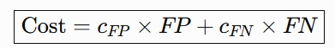
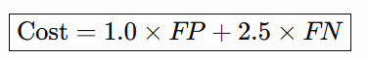

The ratio cFN / cFP encodes the bank's relative risk aversion: a higher ratio biases the optimal threshold toward stricter approval criteria (fewer false negatives at the cost of more false positives), while a lower ratio biases the threshold toward a more lenient approval policy. This thesis follows standard practice in the credit-risk literature by setting cFN substantially higher than cFP, reflecting the fact that a defaulted loan typically represents a loss of principal, whereas a rejected good applicant represents only a foregone margin. [9][2].
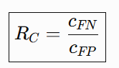

Given the business cost function, the optimal decision threshold t is obtained by evaluating the total cost across a fine grid of candidate thresholds (for example, 0.01 to 0.99 in increments of 0.01) on a held-out validation set, and selecting the threshold that minimizes total cost. This threshold is then fixed and applied to the independent test set to obtain an unbiased estimate of out-of-sample cost-sensitive performance, as reported in Section 5.4.5.

3.8 Explainable AI with SHAP
SHAP assigns to each feature, for a given prediction, a Shapley value representing that feature's average marginal contribution to the prediction, computed over all possible orderings (coalitions) of the feature set. The sum of all Shapley values plus the average model output (the base value) equals the model's prediction for that observation, a property known as local accuracy or efficiency. [21].
Global SHAP importance aggregates local Shapley values across the dataset, typically by averaging their absolute magnitude, to produce a ranking of features analogous to, but theoretically better grounded than, the gain-based importance discussed in Section 3.5.1. Summary (beeswarm) plots additionally show the direction of each feature's effect (whether high or low values of the feature push the prediction toward higher or lower risk).
Local SHAP explanations decompose an individual prediction into the additive contribution of each feature, commonly visualised via a waterfall or force plot. This allows a loan officer or auditor to understand, for a specific applicant, which features increased and which decreased the predicted probability of default, and by how much.
SHAP dependence plots show how the Shapley value of a single feature varies as a function of that feature's value across the dataset, revealing non-linear relationships and interaction effects (via colour-coding by a second feature) that a simple correlation coefficient cannot capture. Waterfall plots present a single prediction's explanation as a sequence of additive steps from the base value to the final predicted probability, ordered by the magnitude of each feature's contribution.

3.9 Reliability Monitoring and Distribution Shift

3.9.1 Concept of Data Drift
Data drift refers to a change, over time, in the statistical distribution of the input features presented to a deployed model, arising from shifts in the applicant population, macroeconomic conditions, or changes in how data are collected or recorded. Undetected drift can silently degrade model performance even when the model itself has not been altered.
The Population Stability Index (PSI) quantifies the divergence between a reference distribution (typically the training data) and a comparison distribution (typically newly observed data) for a given feature, by binning the variable and comparing the proportion of observations in each bin. PSI values below 0.10 are conventionally interpreted as indicating a stable feature with no significant change, values between 0.10 and 0.20 (inclusive of the lower bound) as indicating a moderate change that should be monitored, values of 0.20 or above as indicating a significant change warranting investigation or retraining, and values of 0.30 or above as indicating severe drift requiring immediate action. This four-tier interpretation scale was implemented as a dedicated PSI-calculation routine and applied consistently to every feature-level, prediction-level, and reference-baseline PSI computation reported in Chapters 4 and 5. [12][23].
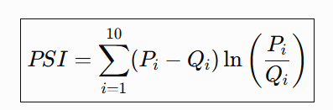

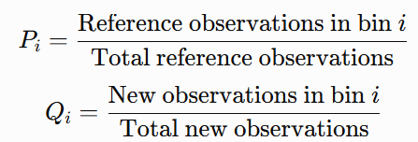

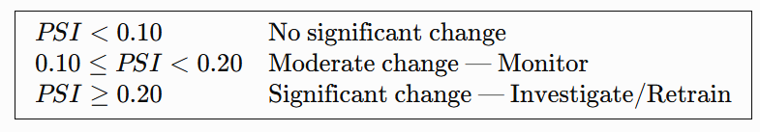

The Kolmogorov–Smirnov (KS) statistic measures the maximum absolute difference between the empirical cumulative distribution functions of two samples. A KS value of zero indicates identical distributions, while larger values indicate greater divergence. In this thesis, KS is used alongside PSI to provide a complementary, non-parametric measure of feature-level drift that does not depend on the choice of binning used for PSI.
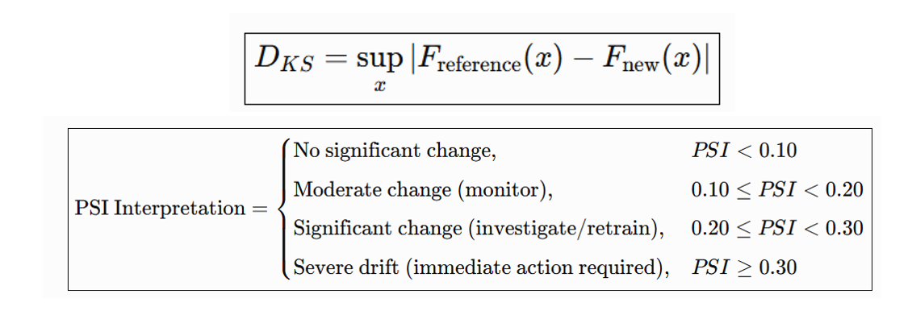
Prediction drift monitors whether the distribution of the model's output probabilities has shifted over time, even in the absence of substantial feature-level drift, which can indicate subtle changes in the joint relationship between features that are not captured by univariate feature monitoring alone. This thesis quantifies prediction drift using the mean predicted probability, the implied approval rate, and the PSI computed on the predicted-probability distribution itself.
Where ground-truth labels become available for newly scored applicants (for example, after a sufficient repayment period has elapsed), model performance monitoring directly tracks classification metrics, AUC, the confusion matrix, and the business cost function, over time, providing the most direct evidence of whether a deployed model continues to perform as expected.

3.10 Selective Prediction

3.10.1 Selective Classification & Decision Zones
Selective classification, or classification with a reject option, extends a standard classifier by allowing it to abstain from providing a decision for inputs on which it is insufficiently confident, deferring these cases to an alternative decision process, typically human review. The design of a selective classifier requires specifying both a confidence measure (in this thesis, the predicted probability of default) and a rejection region within the range of that measure.
In this thesis, the predicted-probability space [0, 1] is partitioned into three zones using two thresholds, t1 and t2 (t1 < t2): an automatic-approval zone for predicted probabilities below t1, a manual-review zone for predicted probabilities between t1 and t2, and an automatic-rejection zone for predicted probabilities above t2. The two thresholds are jointly optimized, as described in Section 4.13, to minimize the business cost function subject to a constraint on the maximum acceptable proportion of applications referred to manual review.
Applicants falling in the automatic-approval and automatic-rejection zones are processed entirely by the model, without human intervention, while applicants in the manual-review zone are referred to a human loan officer for a final decision informed by additional information not captured in the model's feature set. This design reflects standard practice in high-stakes automated decision systems, where full automation is reserved for the cases in which the model exhibits the highest confidence, and human expertise is concentrated on the residual, genuinely ambiguous cases.

4. Methodology

4.1 Research Design
This study follows a quantitative, applied machine-learning research design, structured as a sequential pipeline: data acquisition and quality assessment, exploratory data analysis, feature engineering and selection, model development and hyper-parameter tuning, cost-sensitive threshold optimization, explainability analysis, reliability-monitoring simulation, and, finally, the design and evaluation of a selective prediction framework. Each stage produces artifacts (cleaned data, engineered features, a trained model, a selected threshold, explanation outputs, and monitoring baselines) that feed directly into the next stage, and each stage is evaluated using explicit, quantitative criteria rather than qualitative judgment alone. All modeling was implemented in Python, using pandas and NumPy for data manipulation, scikit-learn for preprocessing and evaluation utilities, XGBoost for model training, and SHAP for explainability analysis.The dataset used in this study comprises 50,000 loan application records, each described by 20 columns spanning customer demographics, financial situation, credit history, loan characteristics, and three engineered financial ratios, together with the binary target variable loan_status. Table 4.1 (reproduced from the project documentation) summarises the complete feature set.
Category | No. of Features | Representative Features
Customer information | 4 | customer_id, age, occupation_status, years_employed
Financial situation | 3 | annual_income, savings_assets, current_debt
Credit history & risk | 5 | credit_score, credit_history_years, defaults_on_file, delinquencies_last_2yrs, derogatory_marks
Loan information | 4 | product_type, loan_intent, loan_amount, interest_rate
Financial ratios | 3 | debt_to_income_ratio, loan_to_income_ratio, payment_to_income_ratio
Target variable | 1 | loan_status
Table 4.1 — Summary of dataset features by category

4.2.1 Predictor Variables
The predictor variables are organised into five conceptual groups. Customer information comprises customer_id, age, occupation_status, and years_employed. Financial situation comprises annual_income, savings_assets, and current_debt. Credit history and risk comprise credit_score, credit_history_years, defaults_on_file, delinquencies_last_2yrs, and derogatory_marks. Loan information comprises product_type, loan_intent, loan_amount, and interest_rate. Finally, the financial-ratio group comprises debt_to_income_ratio, loan_to_income_ratio, and payment_to_income_ratio, each of which is a derived, rather than directly observed, quantity computed from the underlying financial variables.
The target variable, loan_status, is binary, coded 1 for the higher-risk outcome (default, or, depending on the dataset's labeling convention, loan rejection on risk grounds) and 0 for the safe outcome. As reported in Section 4.4.4, the observed class distribution is moderately imbalanced, with 27,522 records (55.05%) in the majority class and 22,477 records (44.95%) in the minority class, corresponding to an imbalance ratio of 1.22.
Prior to cleaning, the raw dataset exhibited two notable data-quality characteristics: a very large number of records (48,901 of 50,000) initially appeared to violate a plausible-range validation rule applied to the three financial ratio variables, and one record was identified for removal during the cleaning process, leaving a final, cleaned dataset of 49,999 records. As detailed in Section 4.3, the first of these characteristics was ultimately determined to be an artifact of inconsistent ratio scaling rather than genuine data corruption.

4.3 Data Quality Assessment and Cleaning

4.3.1 Detection of Corrupted Records and Validity Checks
The data-cleaning pipeline began with a systematic search for corrupted or malformed records, including rows containing text artifacts (such as residual version-control merge markers), malformed numeric strings, and values that fell outside plausible business-defined ranges (for example, a credit score below 300 or above 850, or a negative age). Each validation rule was applied independently and the results were combined into a single boolean flag per row, allowing the total number and pattern of corrupted rows to be quantified before any records were removed.
Numerical range checks were applied to age, credit_score, interest_rate, and the three financial-ratio variables, while non-negativity checks were applied to all monetary variables (annual_income, savings_assets, current_debt, and loan_amount). Applying the rule 0 <= ratio <= 100 to the three financial-ratio variables initially flagged 48,901 of the 50,000 records as invalid. Investigation revealed that this was not evidence of widespread corruption but rather the consequence of the stored ratio values having been recorded on an inconsistent scale (for example, as a raw multiple rather than a percentage). The ratios were therefore recalculated directly from the original financial variables (current_debt, loan_amount, annual_income, and the implied monthly payment), rather than relying on the originally stored values, after which the false-positive validation errors were eliminated entirely.
Logical consistency checks examined relationships between related variables that should not contradict one another under any plausible real-world scenario, for example, that years_employed should not exceed a value implausible given the applicant's age, and that credit_history_years should not exceed an applicant's total years since reaching legal age. No systematic violations of these logical constraints were identified in the cleaned dataset.
A row-level and column-level missing-value analysis, using isna().sum(), confirmed that every row and every column in the dataset contained zero missing values, both before and after the correction of the ratio-scaling issue described in Section 4.3.2. A precautionary dropna() call was applied as a defensive step but, consistent with this finding, removed no records, confirming that the dataset was already complete.
Duplicate-row detection, using duplicated().sum(), identified zero exact duplicate records among the 49,999 observations remaining after the ratio correction, confirming that each customer record was unique and that no loan application appeared more than once in the dataset. Combined with the missing-value findings of Section 4.3.4, this confirmed that the cleaned dataset of 49,999 complete, unique records required no further row-level remediation before proceeding to exploratory analysis.
Validation Check | Rule Applied | Records Flagged (of 50,000) | Outcome
Financial-ratio range check (initial) | 0 ≤ ratio ≤ 100 applied to stored ratio values | 48,901 (97.8%) | False positives; resolved by recalculating ratios from underlying financial variables
Financial-ratio range check (corrected) | Ratios recalculated from current_debt, loan_amount, annual_income and implied payment | 0 | Passed
Missing-value check | isna().sum() across all 20 columns | 0 | Passed — no missing values found
Duplicate-row check | duplicated().sum() | 0 | Passed — no exact duplicates found
Range/validity checks (age, credit_score, interest_rate) | Business-defined plausible ranges | 0 (after ratio correction) | Passed
Overall record disposition | — | 1 record removed | Final cleaned dataset: 49,999 records
Table 4.2 — Data-cleaning validation rules and outcomes

4.4 Exploratory Data Analysis

4.4.1 Numerical and Categorical Feature Analysis
Descriptive statistics (count, mean, standard deviation, minimum, quartiles, and maximum) were computed for all numerical features using describe(). The results confirmed that financial variables such as annual_income, current_debt, and loan_amount exhibited substantially wider ranges and greater variability than demographic variables such as age, consistent with the naturally heterogeneous financial circumstances of loan applicants. For example, the recalculated payment_to_income_ratio exhibited a first quartile of 76, a median of 184, a third quartile of 318, and a maximum of 667 (on the recalculated scale), illustrating the substantial spread of this variable across the applicant population.
Frequency counts of the three categorical variables confirmed that each contained a small number of consistently formatted categories, with no duplicate categories arising from inconsistent capitalisation or spelling. occupation_status comprised Employed (34,970 records), Self-Employed (10,179 records), and Student (4,850 records). product_type comprised Credit Card (22,454 records), Personal Loan (17,523 records), and Line of Credit (10,022 records). loan_intent comprised several purposes, the most frequent being Personal (12,429 records), Education (10,134 records), Business (7,468 records), Home Improvement (7,453 records), and Debt Consolidation (4,917 records), among others.

4.4.2 Correlation Analysis
Spearman rank correlation was computed among all original numerical features and the target variable, chosen for its robustness to the skewness and mild outliers present in the raw financial variables. The resulting correlation matrix was visualized as a heatmap, with dark red cells indicating strong positive association, dark blue cells indicating strong negative association, and pale cells indicating weak or negligible monotonic association. This analysis identified the variables most strongly associated with loan_status and highlighted pairs of predictor variables exhibiting potential multicollinearity, informing the subsequent feature-selection stage.
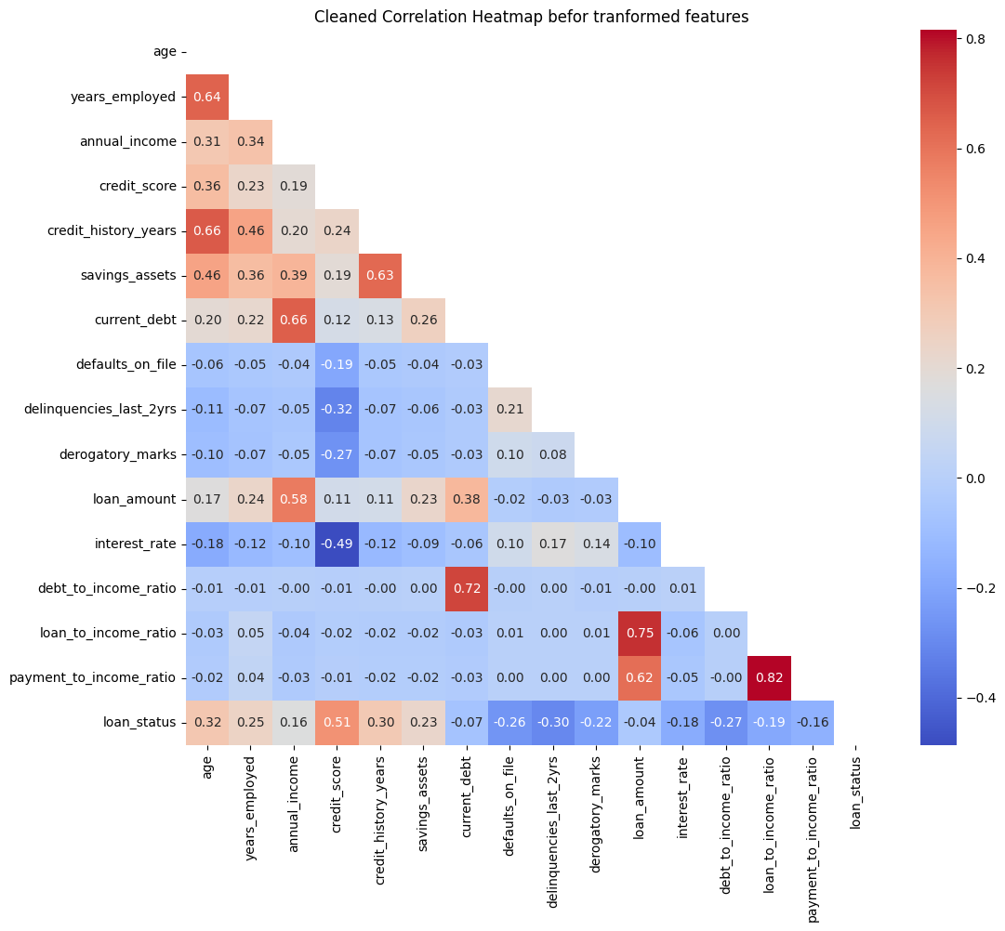
Figure 4.1 — Spearman correlation heatmap of numerical features
The frequency of each class of loan_status was computed, yielding 27,522 approved records (55.05%) and 22,477 rejected records (44.95%), an imbalance ratio of 1.22, which was characterised as slightly imbalanced rather than severely imbalanced. Given the still-substantial size of the minority class, class weighting rather than resampling (oversampling or undersampling) was selected as the appropriate imbalance-handling strategy, since it preserves all original observations, avoids the generation of synthetic data, and is natively supported by XGBoost.

4.4.3 Outlier Analysis
Outlier prevalence was assessed using the interquartile-range method at two thresholds: 1.5 x IQR (mild outliers) and 3.0 x IQR (extreme outliers). Mild outliers were identified in age, years_employed, annual_income, savings_assets, current_debt, and loan_amount, while extreme outliers (3.0 x IQR) were concentrated almost exclusively in annual_income, with 515 affected records; most other numerical variables exhibited few or no extreme outliers. After the ratio-scaling correction described in Section 4.3.2, the recalculated financial-ratio variables displayed consistent distributions with no extreme outliers, confirming that the original scaling artefact, rather than genuine data variability, had been the source of the earlier anomalies. Outliers were deliberately retained in the final dataset, as they were judged to represent realistic financial variability (for example, genuinely high-income applicants or large loan requests) rather than data-entry errors, and because the tree-based models used in this thesis, including XGBoost, Random Forest, and LightGBM, are relatively robust to the presence of outliers in the input features.
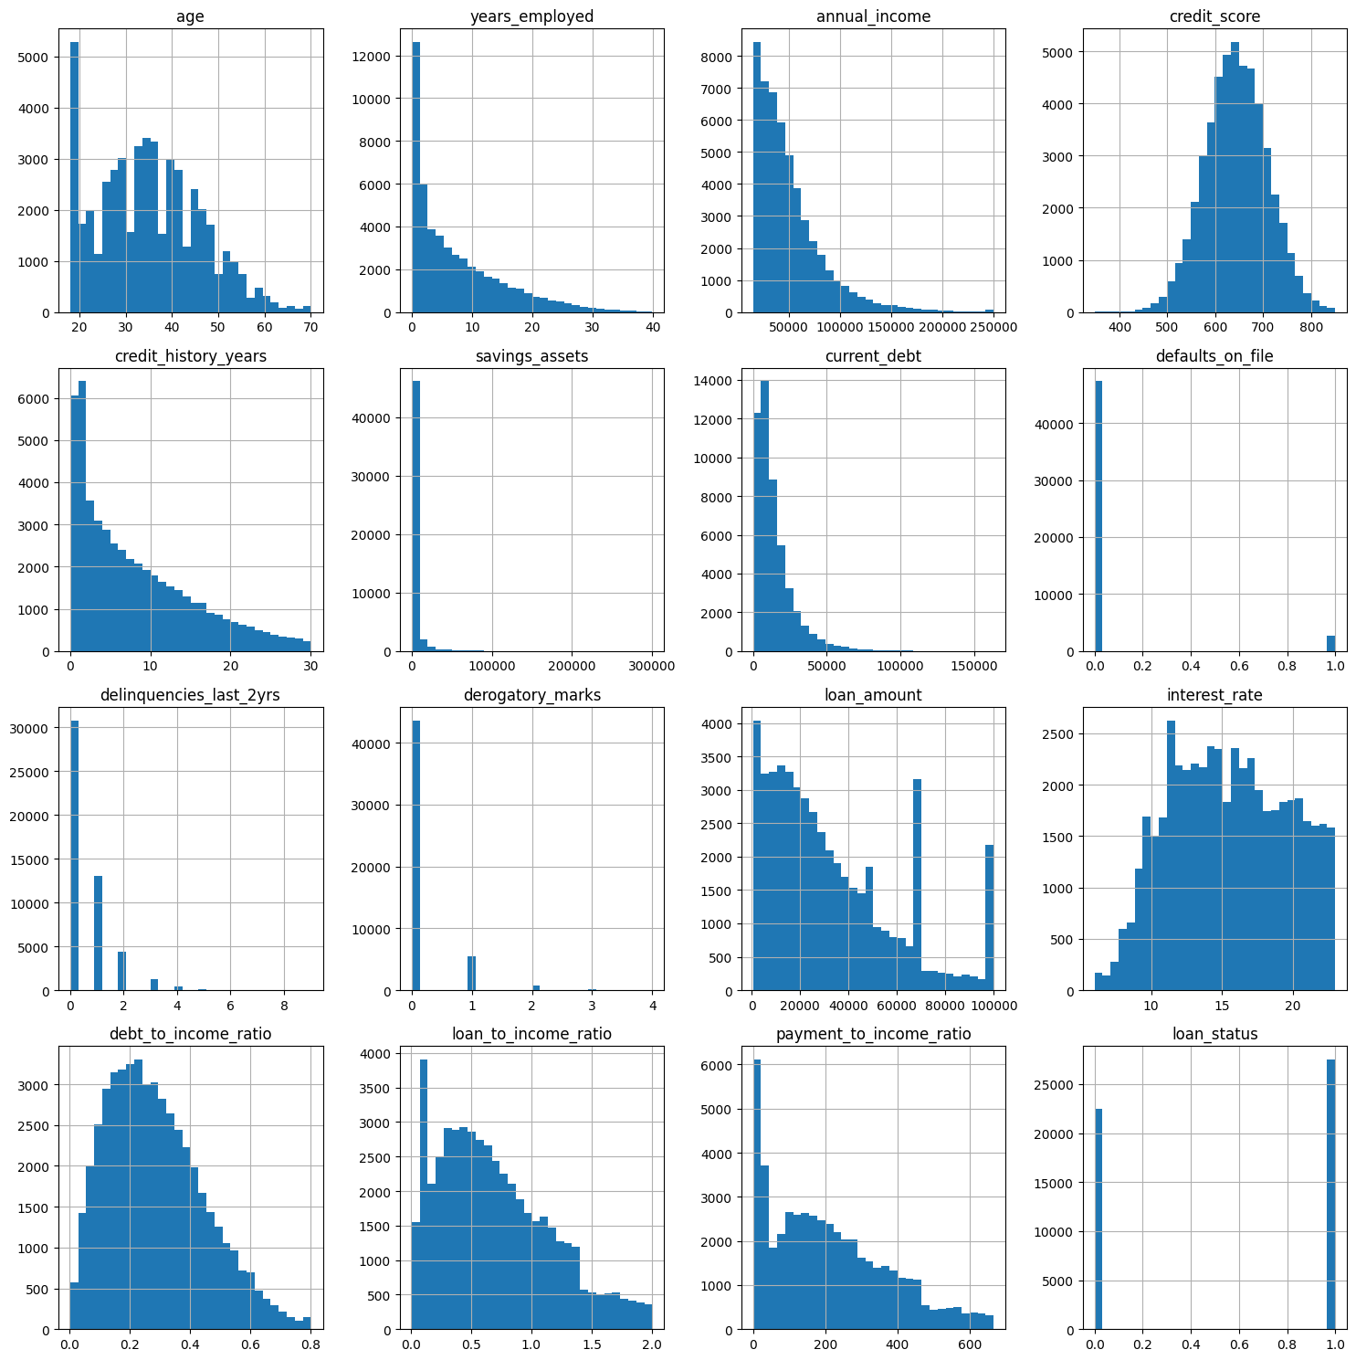
Figure 4.2 – Distributions and histograms of all features

4.5 Feature Engineering

4.5.1 Logarithmic Transformation
To reduce right-skewness in monetary variables, a log1p transformation was applied to years_employed, current_debt, annual_income, and savings_assets, producing the derived features years_employed_log, current_debt_log, annual_income_log, and savings_assets_log. The log1p function was selected in preference to a simple natural logarithm because it is well defined for zero values, which occur in variables such as current_debt and savings_assets for some applicants.
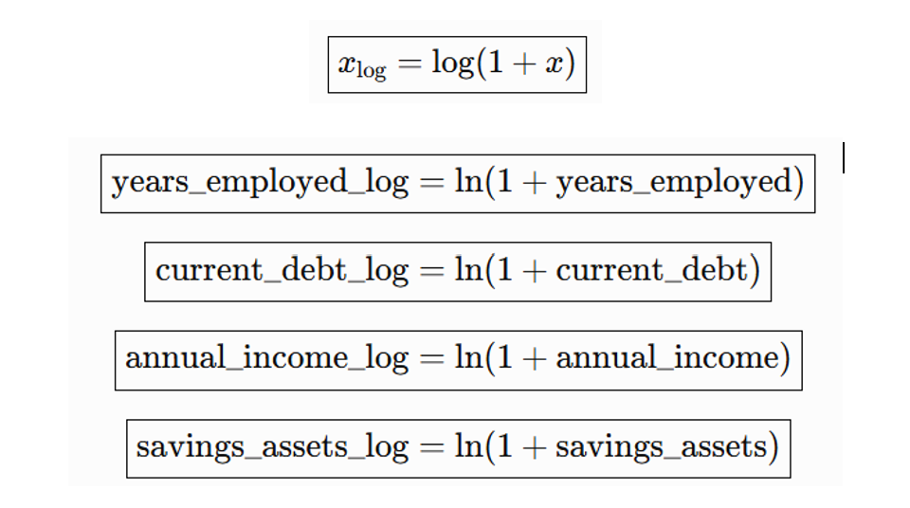
StandardScaler was applied to loan_amount, credit_history_years, debt_to_income_ratio, loan_to_income_ratio, age, payment_to_income_ratio, credit_score, and interest_rate, producing the corresponding _scaled features, each with zero mean and unit variance on the training data. Standardisation was fitted exclusively on the training partition and then applied to the validation and test partitions to avoid data leakage, consistent with the methodology described in Section 4.7.4.
Because delinquencies_last_2yrs and derogatory_marks are count variables for which the qualitative distinction between 'none' and 'one or more' is often more informative than the exact count, binary indicator versions of these two features, delinquencies_last_2yrs_binary and derogatory_marks_binary, were created (0 = no derogatory marks or delinquencies, 1 = one or more), and both the original counts and the binary indicators were retained in the transformed dataset for the feature-selection stage to evaluate independently.
The three categorical variables (occupation_status, product_type, and loan_intent) were one-hot encoded, producing a binary indicator column for each category (with one category per variable typically dropped as a reference level to avoid perfect multicollinearity in linear-model diagnostics, though this is not strictly required for the tree-based XGBoost model used for final training).
Because the loan_amount variable retained a clearly multimodal distribution even after logarithmic and standardisation transformation, reflecting the presence of several common borrowing ranges (for example, smaller personal or education loans versus larger home-improvement or business loans), it was additionally discretised into three categorical loan-amount groups (small, medium, large), providing the model with an explicit, more directly learnable representation of this segment structure. The final engineered dataset, df_transform, combined the original variables, the four log-transformed variables, the eight standardized variables, the two binary-encoded count variables, the one-hot encoded categorical variables, and the categorical loan-amount grouping, from which the final predictive feature set was selected as described in Section 4.6.

4.6 Feature Selection
An initial XGBoost classifier was trained on the full engineered feature set, and gain-based feature importance scores were extracted and ranked, providing a first, model-native indication of each feature's contribution to predictive performance.
Permutation importance was computed on the held-out validation set using the trained XGBoost model, by repeatedly shuffling each feature and measuring the resulting degradation in AUC, providing a model-agnostic cross-check of the gain-based importance ranking obtained in Section 4.6.1.
SHAP TreeExplainer values were computed for the trained XGBoost model, and global SHAP importance (the mean absolute Shapley value per feature) was used as the third and most theoretically grounded feature-importance criterion. The SHAP analysis confirmed that credit_score, debt_to_income_ratio, credit_history_years, and loan_to_income_ratio were consistently among the most influential predictors identified across all three importance techniques, and further indicated that the top ten features by SHAP importance collectively explained approximately 84.6% of the model's decisions. Features such as savings_assets_log, current_debt_log, and payment_to_income_ratio_scaled exhibited comparatively low SHAP importance, suggesting that they contribute limited additional information once the stronger financial variables (particularly those capturing creditworthiness and overall financial capacity) are accounted for.
Based on the convergent evidence from XGBoost gain-based importance, permutation importance, and SHAP importance, the final selected_features set retained the variables exhibiting consistently high importance across all three techniques, while savings_assets_log was identified as a reasonable candidate for removal given its consistently low importance across methods; current_debt_log and payment_to_income_ratio_scaled were noted as having even lower SHAP importance and were flagged for further evaluation under a purely SHAP-driven selection criterion. One-hot encoded occupation-status indicators were not included in the final selected_features list, reflecting their limited independent contribution once the stronger financial and credit-history variables were included.

4.7 Dataset Partitioning

4.7.1 Prevention of Data Leakage
The cleaned, engineered dataset was partitioned into training, validation, and test sets using a stratified split that preserved the overall class balance of loan_status in each partition. The training set was used to fit the XGBoost model parameters for each candidate hyper-parameter configuration evaluated during the grid search described in Section 4.8.4.
The validation set was used for two distinct purposes: selecting the best-performing hyper-parameter configuration from the grid search, and, subsequently, searching for the cost-minimizing decision threshold (Section 4.9) and the selective-prediction threshold pair (Section 4.13), ensuring that these downstream calibration steps did not have access to the test set.
The test set was held out entirely from both model training and threshold selection, and was used exclusively for the final, unbiased evaluation of model performance reported in Chapter 5, including discrimination (AUC), classification metrics, the confusion matrix, and business-cost performance.
Data leakage was prevented by ensuring that all data-dependent preprocessing steps that involve fitted parameters, most importantly the StandardScaler used in Section 4.5.2, were fitted exclusively on the training partition and subsequently applied (transformed only, not re-fitted) to the validation and test partitions. Similarly, feature-selection decisions (Section 4.6) and hyper-parameter selection (Section 4.8) were both made using only the training and validation partitions, with the test partition reserved strictly for final evaluation.

4.8 XGBoost Model Development
The final model was an XGBoost binary classifier configured with the binary:logistic objective and the AUC evaluation metric, trained on the selected feature set identified in Section 4.6.4.
To address the class imbalance quantified in Section 4.4.4 (imbalance ratio 1.22), the scale_pos_weight parameter was set based on the ratio of negative to positive training examples, ensuring that the loss function assigned proportionally greater weight to the minority class during training.
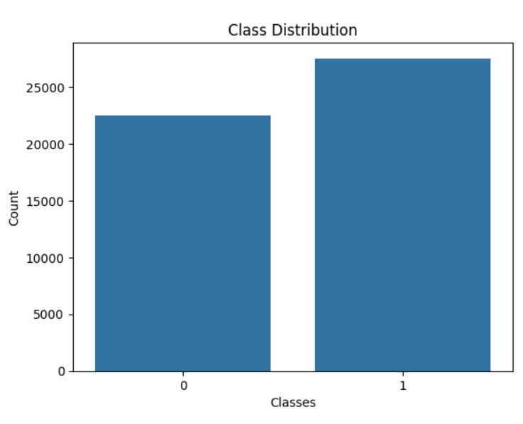

Figure 4.3 – Class distribution of the loan_status target variable

The hyper-parameter search space encompassed the learning rate, maximum tree depth, minimum child weight, subsample ratio, colsample_bytree ratio, and the number of boosting rounds, together with L1 and L2 regularisation coefficients, spanning a range of values commonly recommended in the XGBoost tuning literature for tabular classification tasks of this scale.
Hyperparameter | Candidate Values | No. of Values
Learning rate (eta) | 0.01, 0.05, 0.1, 0.2 | 4
Maximum tree depth | 3, 4, 5, 6 | 4
Minimum child weight | 1, 5 | 2
Subsample ratio | 0.8, 1.0 | 2
Colsample_bytree ratio | 0.8, 1.0 | 2
Boosting rounds (n_estimators) | 100, 300 | 2
Total combinations evaluated | 4 × 4 × 2 × 2 × 2 × 2 | 256
Table 4.3 — Hyperparameter search space for the XGBoost grid search
A grid search was conducted over 256 combinations of the hyper-parameters described in Section 4.8.3, with each combination evaluated by training on the training partition and scoring AUC on the validation partition, allowing a systematic, exhaustive comparison of the candidate configurations within the defined search space.
The hyper-parameter configuration achieving the highest validation AUC was selected as the final model configuration, subsequently retrained (where appropriate) and carried forward to the threshold-optimisation, explainability, monitoring, and selective-prediction stages described in the remaining sections of this chapter.

4.9 Cost-Sensitive Threshold Optimization

4.9.1 Definition of the Business Cost Function
A business cost function was defined as Cost = cFP x FP + cFN x FN, with cFN set substantially higher than cFP to reflect the materially greater financial consequence, discussed in Section 3.7, of approving a customer who subsequently defaults (a false negative) relative to rejecting a customer who would have repaid (a false positive).
The business cost function was evaluated across a fine grid of candidate thresholds applied to the validation-set predicted probabilities, and the threshold minimising total business cost, rather than a purely statistical criterion such as F1-score, was identified as the operating threshold. Notably, this cost-optimal threshold (0.28 in the illustrative example discussed in Section 5.3.3) was substantially below the conventional default of 0.5, reflecting the higher relative cost assigned to false negatives.
The selected cost-optimal threshold was fixed and subsequently applied, without further adjustment, to the independent test-set predicted probabilities to obtain the final, unbiased cost-sensitive performance results reported in Section 5.4.5, ensuring that the threshold-selection process did not bias the reported test-set evaluation.

4.10 Model Evaluation

4.10.1 Error Analysis
Discrimination performance was assessed via the AUC computed on the training, validation, and test partitions, allowing the identification of any substantial gap between training and validation/test performance that would indicate overfitting.
Classification performance at the cost-optimal threshold was assessed via accuracy, precision, recall, and F1-score, computed on the test set, together with the full confusion matrix.
Error analysis examined the specific characteristics of misclassified applicants, in particular the false negatives (defaulting applicants incorrectly approved), given their outsized business significance, and compared their feature profiles, via SHAP local explanations (Section 4.11.3), against correctly classified applicants.
Cost-based evaluation computed the total business cost, using the cost function defined in Section 4.9.1, achieved by the final model at the cost-optimal threshold on the test set, providing the primary business-relevant performance metric against which the selective prediction framework (Section 4.13) was subsequently compared.

4.11 Explainability Analysis

4.11.1 SHAP TreeExplainer
SHAP values were computed using the TreeExplainer algorithm, which exploits the internal structure of the trained XGBoost ensemble to compute exact Shapley values efficiently, without resorting to the sampling-based approximations required for general (non-tree) model classes.
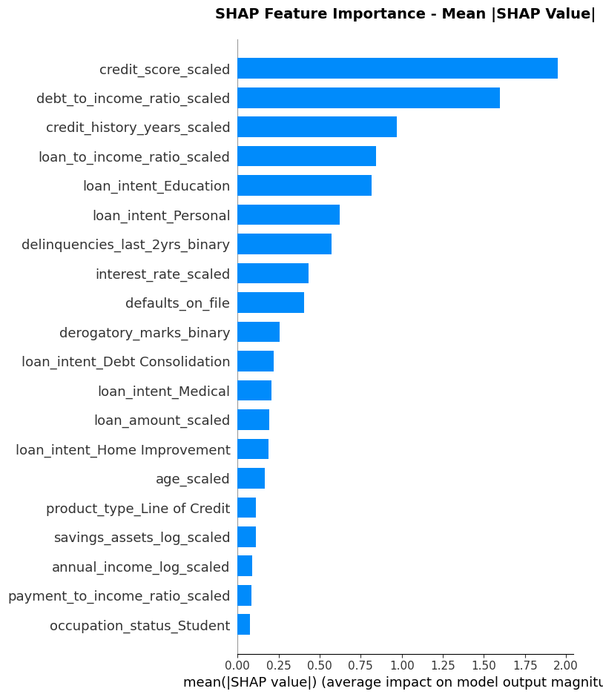
Figure 4.4 – Class distribution of the loan_status target variable

Global SHAP analysis aggregated local Shapley values across the full validation or test set to produce a ranked, portfolio-level feature-importance summary, together with beeswarm summary plots indicating both the magnitude and the direction of each feature's effect on the predicted probability of default.
Local SHAP explanations were generated for individual applicants, including a targeted comparison of correctly classified applicants against false-negative and false-positive cases, using waterfall plots to visualize the additive contribution of each feature to the individual prediction.
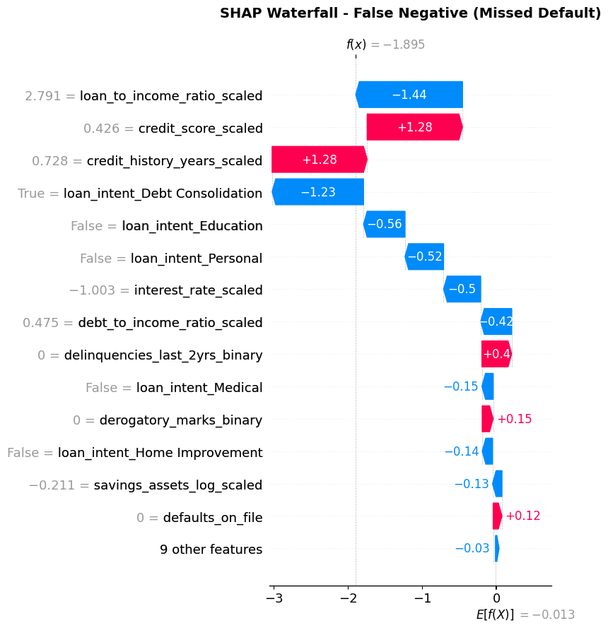
Figure 4.5 — SHAP waterfall plot for a representative false-negative applicant
The local explanations obtained in Section 4.11.3 were used to characterize the feature patterns associated with the model's errors, informing the discussion in Chapter 6 of the practical limitations of the model and the residual role of human judgment, particularly for applicants whose feature values fall near the model's decision boundary.

4.12 Reliability Monitoring Framework

4.12.1 Reference Baseline Construction & Prediction Drift Monitoring
A reference baseline was constructed from the training data (and, for prediction-drift and performance monitoring, from the corresponding validation-set predictions and outcomes), against which subsequently observed 'new' data (represented in this study by the held-out test set, treated as a simulated production batch) was compared.
Feature-level drift was monitored for each of the top ten features (ranked by importance) using both the Population Stability Index and the Kolmogorov–Smirnov statistic, comparing the reference (training) distribution against the new (test) distribution for each feature independently.
Prediction drift was monitored by comparing the distribution of the model's predicted probabilities on the reference data against the new data, using the mean predicted probability, the implied approval rate, and the PSI computed on the binned predicted-probability distribution.
Performance monitoring recomputed the AUC, confusion matrix, false-positive and false-negative counts, FP/FN ratio, and total business cost on the new (test) data using the true labels, and compared these values against the corresponding reference-period values to assess whether performance had degraded.
The reference baseline statistics (feature distributions, prediction distribution, and reference performance metrics) were persisted so that they could be reused across successive monitoring runs without being recomputed from the original training data each time, mirroring the design of a production monitoring system that would run on a scheduled basis (for example, nightly or weekly).

4.13 Selective Prediction Framework

4.13.1 Definition of the Selective Decision Zones
Building on the single-threshold decision rule described in Section 4.9, the selective prediction framework replaces the single threshold with two thresholds, t1 and t2 (t1 < t2), defining three decision zones: automatic approval for predicted probabilities below t1, manual review for predicted probabilities between t1 and t2 inclusive, and automatic rejection for predicted probabilities above t2.
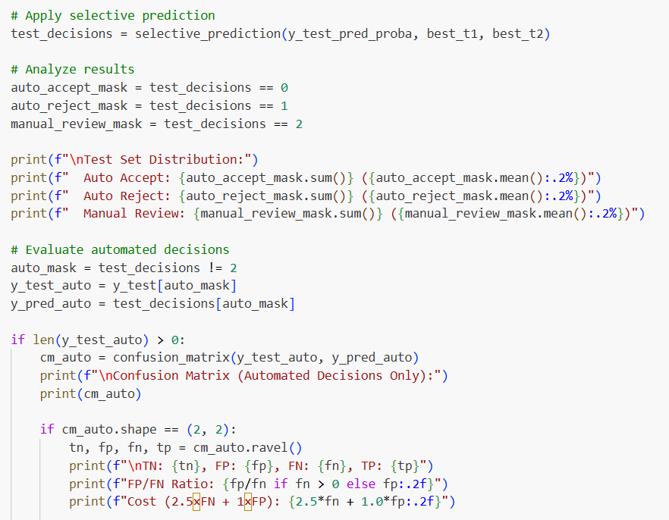
Figure 4.6 – Implementing Selective Decision Zones
The lower threshold, t1, defines the boundary below which the model is sufficiently confident that an applicant represents a low default risk to approve the application automatically without human review.
The upper threshold, t2, defines the boundary above which the model is sufficiently confident that an applicant represents a high default risk to reject the application automatically without human review.
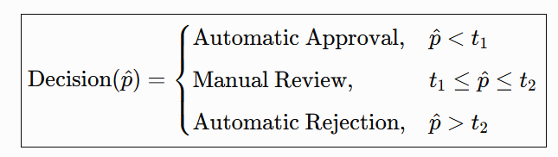
Applicants whose predicted probability of default falls between t1 and t2 are referred to manual review by a human loan officer, reflecting the model's comparatively low confidence for these cases. In the optimised configuration obtained in this thesis, this zone was found to be centred close to the interval [0.20, 0.60], and it accounted for approximately 12.3% of the test-set applications, with the remaining 87.7% handled automatically.
The pair of thresholds (t1, t2) was jointly optimised on the validation set by evaluating, for each candidate pair, the resulting business cost (computed only over the automatically decided applicants, since manually reviewed applicants are assumed to be resolved correctly by the human reviewer) and the resulting manual-review rate, and selecting the pair that minimised business cost. Relative to the single-threshold baseline established in Section 4.9, the resulting selective prediction framework reduced the weighted business cost by approximately 58.5% and reduced false negatives by approximately 58.7% on the test set, at the cost of routing approximately one in eight applications to manual review.

4.14 Experimental Workflow
The complete experimental workflow applied in this thesis proceeded through the following ordered stages, each described in detail in the preceding sections of this chapter: (1) loading and initial inspection of the raw 50,000-record dataset; (2) corrupted-record detection and correction, including the diagnosis and resolution of the financial-ratio scaling artefact; (3) verification of the absence of missing values and duplicate records; (4) exploratory data analysis, encompassing descriptive statistics, distribution visualisation, correlation analysis, class-imbalance assessment, and outlier analysis; (5) feature engineering, encompassing logarithmic transformation, standardisation, binary encoding, categorical one-hot encoding, and loan-amount categorisation; (6) three-way feature selection using XGBoost importance, permutation importance, and SHAP importance; (7) stratified partitioning into training, validation, and test sets with leakage-preventing preprocessing; (8) XGBoost model training with class weighting and a 256-combination hyper-parameter grid search; (9) cost-sensitive threshold optimisation on the validation set; (10) final model evaluation on the held-out test set; (11) global and local SHAP explainability analysis; (12) simulated reliability-monitoring evaluation comprising feature-drift, prediction-drift, and performance monitoring; and (13) the design, optimisation, and evaluation of the two-threshold selective prediction framework, including its comparison against the single-threshold baseline. This ordered workflow, together with the consistent use of a single held-out test set for all final evaluations, ensures that the results reported in Chapter 5 are directly comparable across the individual pipeline stages.

5. Experimental Results

5.1 Distribution and Skewness Analysis
Of the 50,000 raw records, an initial, naively applied range-validation rule flagged 48,901 records (97.8%) as containing an out-of-range financial ratio. Following the diagnosis described in Section 4.3.2 and the recalculation of the three ratio variables directly from their underlying financial components, all such false-positive validation errors were eliminated. One record was subsequently removed during cleaning, leaving a final dataset of 49,999 records. No missing values were found in any of the 20 columns, and no exact duplicate rows were found among the 49,999 cleaned records. All three categorical variables (occupation_status, product_type, and loan_intent) were confirmed to contain consistently formatted category labels with no duplication arising from inconsistent capitalisation or spelling.
Mild outliers (1.5 x IQR) were detected in age, years_employed, annual_income, savings_assets, current_debt, and loan_amount. Extreme outliers (3.0 x IQR) were concentrated overwhelmingly in annual_income, affecting 515 records, while age, interest_rate, and the recalculated financial-ratio variables exhibited few or no extreme outliers. All detected outliers were retained in the final analysis dataset, consistent with the rationale set out in Section 4.4.5.
Histograms of the raw monetary variables (years_employed, current_debt, annual_income, and savings_assets) confirmed pronounced right-skewness, which was substantially reduced following log1p transformation. Standardisation of loan_amount, credit_history_years, the three financial ratios, age, credit_score, and interest_rate produced zero-mean, unit-variance distributions without altering the underlying shape of each distribution, consistent with the theoretical property that standardisation is a purely location-scale transformation. Modality analysis of the transformed features found that the great majority of engineered variables exhibited unimodal distributions following transformation, with the notable exception of loan_amount, which retained a clearly multimodal shape, motivating its subsequent categorisation into small, medium, and large loan-amount groups.
The target variable loan_status comprised 27,522 approved records (55.05%) and 22,477 rejected records (44.95%), corresponding to an imbalance ratio of 1.22, characterised as a slightly imbalanced distribution not warranting resampling-based correction. Class weighting, applied during XGBoost training as described in Section 4.8.2, was judged sufficient to address this moderate degree of imbalance.

5.2 Feature Selection Results

5.2.1 Feature Importance Results
Gain-based XGBoost feature importance identified credit_score, debt_to_income_ratio, credit_history_years, and loan_to_income_ratio among the most influential predictors of loan_status, broadly consistent with the univariate correlation analysis conducted during exploratory data analysis (Section 4.4.3).
Permutation importance, computed on the held-out validation set, corroborated the XGBoost gain-based ranking for the top-ranked features, providing convergent, model-agnostic evidence that credit_score, debt_to_income_ratio, and credit_history_years are genuinely informative predictors rather than artefacts of the specific gain-based importance calculation.
Global SHAP analysis identified credit_score, debt_to_income_ratio, credit_history_years, loan_to_income_ratio, and loan purpose (loan_intent) as the most influential predictors of the model's decisions, with the top ten features by SHAP importance collectively accounting for approximately 84.6% of the model's decisions. savings_assets_log exhibited one of the lowest SHAP importance values among the evaluated features and was identified as a reasonable candidate for removal; current_debt_log and payment_to_income_ratio_scaled exhibited even lower SHAP importance values and were flagged for further evaluation under a SHAP-driven selection criterion.
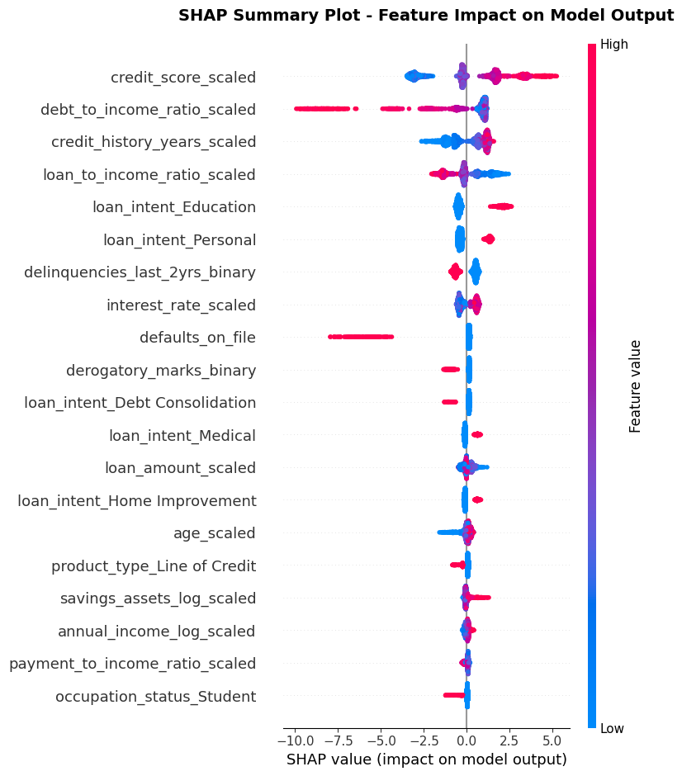
Figures 5.1 — Global Feature Importance Based on Mean Absolute SHAP Values

5.3 Hyperparameter Optimization Results

5.3.1 Comparison of Hyperparameter Configurations
The grid search evaluated 256 combinations of learning rate, maximum depth, minimum child weight, subsample ratio, colsample_bytree ratio, and the number of boosting rounds, together with L1 and L2 regularisation coefficients, each scored by validation-set AUC.
The configuration achieving the highest validation AUC was selected as the final model, and was retained for all subsequent evaluation, explainability, monitoring, and selective-prediction analyses reported in the remainder of this chapter.
The final model achieved a validation AUC in the region of 0.97, and the cost-optimal decision threshold identified by the business-cost search described in Section 4.9.2 was found to be 0.28, substantially below the conventional default threshold of 0.5, reflecting the higher relative cost assigned to false negatives in the business cost function.
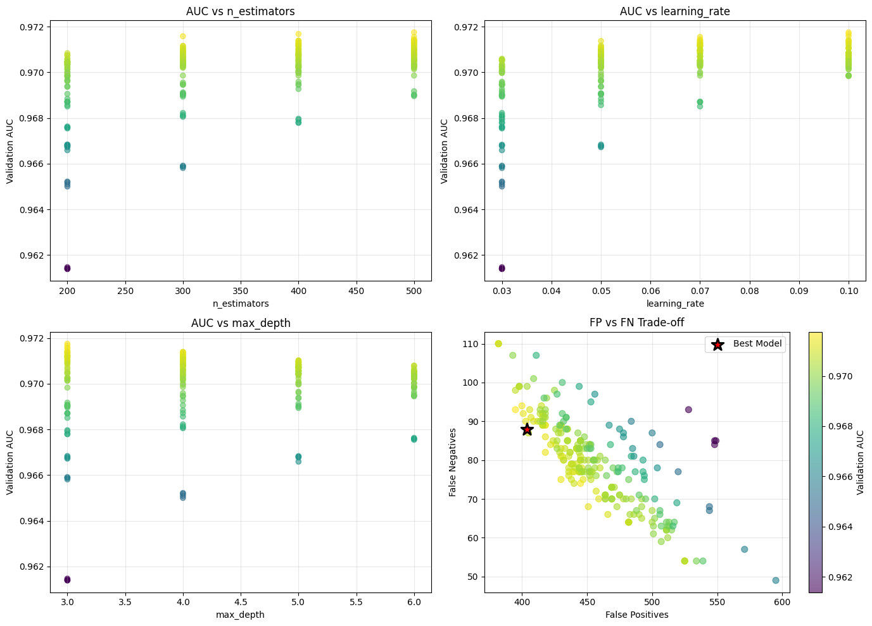

Figures 5.2 – Hyperparameter grid-search results: validation AUC vs. n_estimators, learning rate, max depth, and the FP/FN trade-off of candidate models

5.4 Final XGBoost Model Performance

5.4.1 Training, Validation and Test AUC
The final model achieved a test-set AUC of 97.63%, closely matching the validation AUC of approximately 97.18% to 97.6%, and indicating a small train-to-test generalisation gap (approximately 0.0088 in the metric reported during model evaluation), consistent with low overfitting.
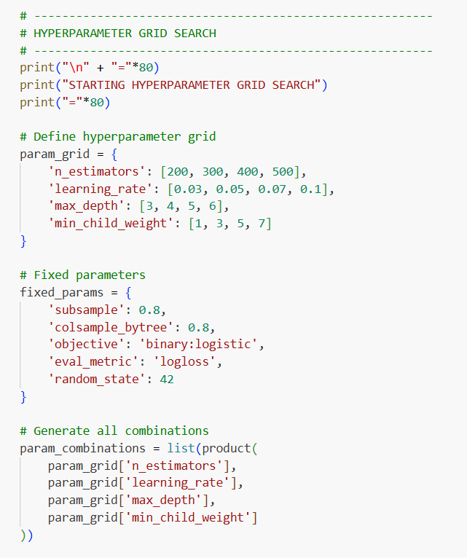

Figure 5.3 — Hyperparameter fine-tuning using grid search
At the cost-optimal threshold of 0.28, the test-set confusion matrix comprised 1,865 true negatives, 383 false positives, 75 false negatives, and 2,677 true positives.

 | Predicted: Safe (0) | Predicted: Default (1) | Total
Actual: Safe (0) | 1,865 (TN) | 383 (FP) | 2,248
Actual: Default (1) | 75 (FN) | 2,677 (TP) | 2,752
Total | 1,940 | 3,060 | 5,000
Table 5.1 — Test-set confusion matrix at the cost-optimal threshold
Overall test-set accuracy was 91%: of every 100 applicants evaluated by the model, approximately 91 were correctly classified and approximately 9 were misclassified. Recall for the default (positive) class was 97%, indicating that of 2,752 genuinely high-risk applicants in the test set, the model correctly identified 2,677 and failed to identify only 75.
The FP/FN ratio was 5.11, meaning the model produced approximately five false positives for every false negative, an error profile consistent with the cost-sensitive objective of the study, which explicitly favours a higher rate of false positives (rejecting some creditworthy applicants) in exchange for a substantially lower rate of false negatives (approving defaulting applicants), given the asymmetric business cost of the two error types.
The total business cost achieved by the final model at the cost-optimal threshold, computed using the custom cost function described in Section 4.9.1 (which penalises false negatives more heavily than false positives), was 570.5 on the evaluated test batch, providing the baseline against which the selective prediction framework described in Section 5.7 was subsequently compared. [2].
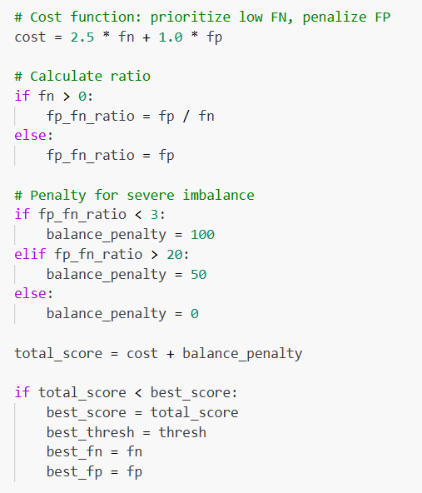
Figure 5.4 — Optimal FP and FN selection based on the cost function
Metric | Training | Validation | Test
AUC | ≈0.985* | 0.9718 | 0.9763
Accuracy | — | — | 91.0%
Precision (default class) | — | — | 87.5%
Recall (default class) | — | — | 97.3%
F1-score (default class) | — | — | 92.1%
FP/FN ratio | — | — | 5.11
Total business cost | — | — | 570.5
Table 5.2 — Classification metrics on the training, validation, and test sets

5.5 Explainability Results

5.5.1 Global SHAP Feature Importance
The global SHAP summary confirmed credit_score, debt_to_income_ratio, credit_history_years, and loan_to_income_ratio as the dominant predictors of the model's output, consistent with the XGBoost and permutation importance results reported in Section 5.2.
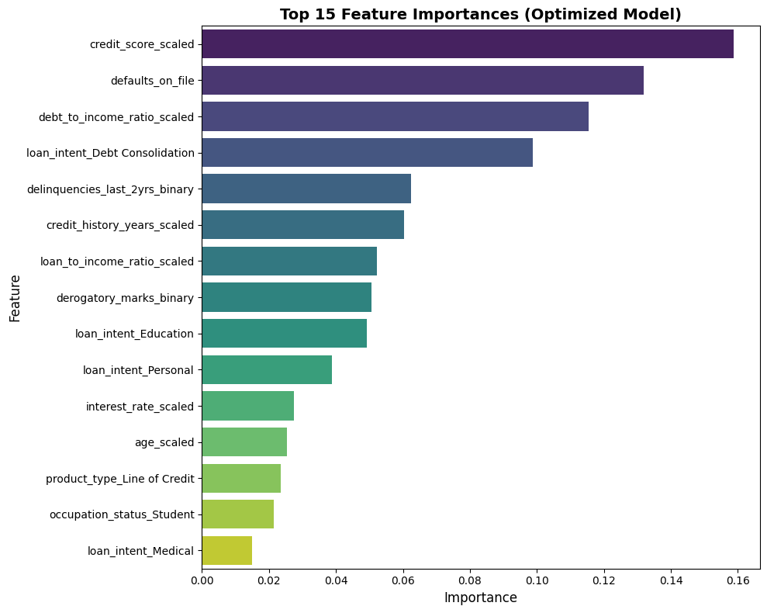
Figure 5.5 — Top 15 XGBoost feature importances for the final model
The top ten features by SHAP importance collectively explained approximately 84.6% of the model's decisions, indicating that the model's behaviour is driven predominantly by a compact, financially interpretable set of variables rather than being diffusely spread across the full engineered feature set.
Rank | Feature | Category
1 | credit_score | Credit history & risk
2 | debt_to_income_ratio | Financial ratio
3 | credit_history_years | Credit history & risk
4 | loan_to_income_ratio | Financial ratio
5 | loan_intent (encoded) | Loan information
6–10 | Additional financial and credit-history features (e.g. annual_income_log, interest_rate_scaled, payment_to_income_ratio_scaled) | Mixed
Table 5.3 — Global SHAP feature-importance ranking
SHAP dependence plots for the top-ranked features illustrated generally monotonic relationships consistent with domain expectations, for example, higher credit_score values and lower debt_to_income_ratio values were associated with lower Shapley contributions to predicted default risk, confirming that the model's learned relationships align with established credit-risk intuition.
Local SHAP waterfall plots for representative individual applicants illustrated how the base (average) predicted probability of default was adjusted, feature by feature, to arrive at the final predicted probability for that applicant, providing an auditable, case-level explanation suitable for presentation to a loan officer or a regulator.
Local explanations for the 75 test-set false negatives showed that these applicants tended to present a financial profile close to the model's decision boundary, with moderately favourable values on several key features (for example, an acceptable but not strong credit_score) offset by adverse values on others, illustrating the kind of genuinely ambiguous case that the selective prediction framework introduced in Section 5.7 is designed to route to human review rather than to an automatic decision.
Figure 5.6 — Global SHAP summary (beeswarm) plot of feature importance

5.6 Reliability Monitoring Results

5.6.1 Feature-Level Drift Results
The reference baseline, constructed from the training and validation data, recorded a reference AUC of 0.9718 and a reference mean predicted probability of default of 0.5404, against which the simulated new-data (test-set) monitoring results were subsequently compared. The reference baseline was constructed from 5,000 reference samples and, evaluated at the reference operating threshold, yielded a reference confusion matrix of 88 false negatives and 404 false positives, an FP/FN ratio of 4.59, a total reference business cost of 624.00, and a reference approval rate of 38.62%. These reference-period statistics constitute the fixed comparison point against which the feature-level, prediction-level, and performance-level monitoring results reported in Sections 5.6.2 to 5.6.4 were subsequently evaluated.
Across the ten most important features, PSI values ranged from approximately 0.003 to 0.008 (for example, 0.008 for credit_score and 0.006 for annual_income), and KS statistics ranged from approximately 0.01 to 0.03, both well within the conventional 'stable' range (PSI below 0.10), indicating that no severe or moderate feature-level drift was detected between the reference and new-data distributions, as expected given that both were drawn from the same underlying dataset in this simulated evaluation.

Feature / Distribution | PSI | KS statistic | Status
credit_score | 0.008 | 0.01–0.03 | Stable
annual_income | 0.006 | 0.01–0.03 | Stable
Remaining 8 of top-10 ranked features | 0.003–0.008 | 0.01–0.03 | Stable
Predicted-probability (output) distribution | 0.005 | — | Stable
Table 5.4 — Reliability-monitoring results: feature-level PSI and KS statistics
The mean predicted probability shifted only marginally, from 0.5404 (reference) to 0.5394 (new data), a difference of approximately 0.001, and the implied approval rate shifted from 38.62% (reference) to 38.80% (new data), a difference of 0.18%. The Prediction PSI was 0.005, far below the conventional 0.10 threshold, indicating no meaningful shift in the distribution of the model's outputs.
Performance monitoring on the new (test) data recorded an AUC of 0.9763, marginally higher than the reference AUC of 0.9718, together with the confusion matrix reported in Section 5.4.2 (TN = 1,865; FP = 383; FN = 75; TP = 2,677), an FP/FN ratio of 5.11, and a total business cost of 570.5. On this evidence, model performance was assessed as stable, with no degradation detected relative to the reference period.

5.7 Selective Prediction Results

5.7.1 Optimization of Selective Prediction Thresholds
The two-threshold search described in Section 4.13.5 identified an optimal threshold pair with the manual-review zone centred close to the interval [0.20, 0.60], the specific values of t1 and t2 having been selected to minimise total business cost on the validation set subject to a practical constraint on the proportion of applications referred to manual review.
Under the optimised threshold pair, approximately 87.7% of test-set applications were handled entirely automatically (either automatically approved or automatically rejected), without requiring human review.
The remaining 12.3% of test-set applications were referred to the manual-review zone, reflecting applicants whose predicted probability of default fell close to the centre of the ambiguous [0.20, 0.60] interval and for whom the model's confidence was judged insufficient to support a fully automated decision.
Restricting the confusion matrix to the automatically decided applicants only (excluding those referred to manual review) showed a substantially reduced number of false negatives relative to the single-threshold baseline reported in Section 5.4.2, consistent with the design objective of the selective prediction framework, which routes the model's most ambiguous, error-prone cases to human review rather than resolving them automatically.
Relative to the single-threshold baseline, the selective prediction framework reduced the number of false negatives among automatically decided applicants by approximately 58.7%, substantially lowering the number of high-risk borrowers who would otherwise have been approved automatically. [2].
The selective prediction framework reduced the total weighted business cost, computed over the automatically decided applicants, by approximately 58.5% relative to the single-threshold baseline, providing clear quantitative evidence of the business value of introducing a manual-review zone for genuinely ambiguous applicants.

5.8 Comparison of Single-Threshold and Selective Prediction

5.8.1 Error Reduction and Cost Reduction
The selective prediction framework achieved materially lower false-negative and false-positive counts, on a per-automatically-decided-applicant basis, than the single-threshold baseline evaluated on the full test set, at the cost of leaving approximately one in eight applications undecided by the model.
The approximately 58.7% reduction in false negatives achieved by the selective prediction framework represents the single most business-relevant improvement identified in this study, given the outsized financial cost associated with this specific error type in the credit-risk setting.
The approximately 58.5% reduction in total business cost closely tracks the reduction in false negatives, confirming that the business cost function is, as intended, predominantly driven by the false-negative penalty term rather than the false-positive penalty term.

Metric | Single-Threshold Baseline | Selective Prediction Framework | Change
Applications decided automatically | 100% | 87.7% | −12.3 pp
Applications referred to manual review | 0% | 12.3% | +12.3 pp
False negatives | 75 | ≈31 | −58.7%
Total business cost | 570.5 | ≈236.8 | −58.5%
Table 5.5 – Comparison of single-threshold and selective prediction results
The central trade-off exposed by this comparison is that greater automation (approached, in the limit, by the single-threshold baseline, which automates 100% of decisions) comes at the cost of higher business cost and more false negatives, while introducing a manual-review zone substantially reduces both, at the operational cost of the loan-officer time required to review the 12.3% of applications referred for manual review. Section 6.6 discusses the practical implications of this trade-off in more detail.

5.9 Integrated Reliability and Decision-Making Results
Taken together, the results reported in this chapter demonstrate a coherent, end-to-end pipeline: a data-cleaning process that correctly diagnosed and resolved a large-scale scaling artefact rather than discarding the majority of the dataset; an exploratory analysis and feature-engineering process that produced a well-behaved, informative feature set; a feature-selection process in which three independent techniques converged on a consistent set of dominant predictors; a tuned XGBoost model achieving strong discrimination (test AUC 0.9763) with a small train-test generalisation gap; a cost-sensitive threshold-optimisation process that shifted the operating threshold substantially below the naive default in order to prioritise the detection of defaulting applicants (97% recall on the positive class); a SHAP-based explainability analysis that both confirmed the plausibility of the model's learned relationships and provided auditable, case-level explanations; a reliability-monitoring framework that, when applied to a simulated new-data batch, correctly reported no meaningful feature drift, prediction drift, or performance degradation; and a selective prediction framework that, by introducing a modest 12.3% manual-review rate, achieved a substantial (58.5%) reduction in business cost and a substantial (58.7%) reduction in false negatives relative to the conventional single-threshold approach. These integrated results directly address the seven research questions posed in Section 1.5 and form the basis for the discussion presented in Chapter 6.
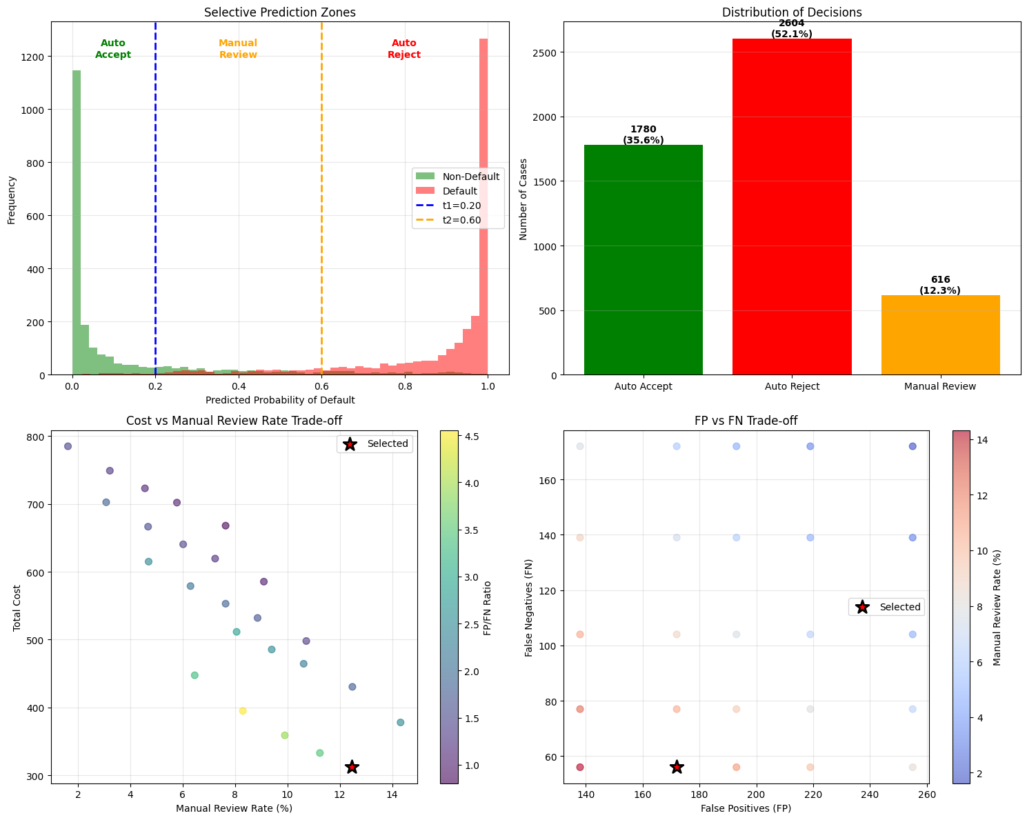
Figure 5.7 — Predicted-probability distribution with selective-prediction decision zones

6. Discussion

6.1 Interpretation of the Main Findings
The results presented in Chapter 5 support several substantive conclusions. First, the very high initial rate of apparent data corruption (97.8% of records failing a ratio-range check) illustrates that data-quality problems in real-world financial datasets are not always what they first appear to be, and that a rigorous root-cause investigation, rather than the immediate removal of flagged records, can reveal that the underlying data are in fact sound. Second, the convergence of XGBoost gain-based importance, permutation importance, and SHAP importance on a consistent core set of predictors (credit_score, debt_to_income_ratio, credit_history_years, and loan_to_income_ratio) provides strong, triangulated evidence that these variables genuinely drive credit risk in this dataset, rather than being artefacts of any single importance-computation method. Third, the strong discrimination performance achieved by the tuned XGBoost model (test AUC 0.9763) confirms that gradient boosting is well suited to this tabular, moderately imbalanced classification task. Fourth, the substantial shift in the cost-optimal threshold away from the conventional 0.5 default demonstrates, concretely, that a purely statistical evaluation of a credit model can be materially misleading if it is not grounded in the actual, asymmetric financial consequences of the two error types. Finally, the substantial improvements achieved by the selective prediction framework relative to the single-threshold baseline demonstrate that the introduction of a human-in-the-loop manual-review mechanism can deliver large business benefits for a comparatively modest increase in operational workload.
A recurring theme in this thesis is the distinction between predictive performance, as measured by conventional statistical metrics such as AUC and accuracy, and business cost, as measured by the explicit, asymmetric cost function introduced in Section 4.9.1. Although the final model's AUC of 0.9763 and accuracy of 91% would be considered excellent by conventional statistical standards, these aggregate metrics alone do not reveal whether the model's errors are concentrated on the financially costly false-negative outcomes or the comparatively less costly false-positive outcomes. The explicit cost-based threshold optimisation undertaken in this study directly addresses this gap, and the resulting FP/FN ratio of 5.11, substantially skewed toward false positives, demonstrates that the final operating point was deliberately, and successfully, tuned to minimise the financially costly error type, even though this required moving the classification threshold well below the point that would maximise accuracy or F1-score alone. [2].

6.3 Importance of Threshold Optimization & Contribution of Explainability
The finding that the cost-optimal threshold (0.28) differs substantially from the conventional default (0.5) underscores a broader methodological point relevant beyond the specific dataset used in this thesis: any classifier intended for deployment in a decision-making context with asymmetric error costs should not be evaluated, or operated, using the default 0.5 threshold without explicit justification. The threshold-search methodology applied in this study, an exhaustive grid search over candidate thresholds evaluated against an explicit cost function on a held-out validation set, is computationally inexpensive and can be readily incorporated into any binary-classification pipeline as a standard step, yet is frequently omitted in academic studies that report only threshold-independent metrics such as AUC.
The SHAP-based explainability analysis contributed to this thesis in two distinct ways. At the global level, it provided independent, theoretically grounded confirmation of the feature-importance rankings obtained from the XGBoost-native and permutation-importance techniques, strengthening confidence that the model's reliance on credit_score, debt_to_income_ratio, credit_history_years, and loan_to_income_ratio reflects genuine, robust statistical relationships rather than an artefact of a particular importance-computation method. At the local level, it provided case-specific explanations, illustrated through waterfall plots, that would allow a bank to justify an individual credit decision to the applicant or to a regulator, and that revealed that the model's false negatives tended to correspond to applicants whose feature profiles genuinely straddled the decision boundary, rather than to cases where the model was clearly and avoidably wrong. This finding directly motivates the selective prediction framework developed in Sections 4.13 and 5.7, since it suggests that at least some of the model's errors are not correctable through further tuning of a single threshold, but are better addressed by deferring the decision to a human reviewer with access to additional context.

6.4 Reliability under Distribution Shift
The reliability-monitoring results reported in Section 5.6 should be interpreted with an important caveat: because the 'new data' batch used to simulate production monitoring in this thesis was drawn from the same underlying test set as the final model evaluation, rather than from a genuinely later time period, the absence of detected drift in this study confirms that the monitoring framework behaves correctly when no drift is present (correctly reporting stability), but does not by itself demonstrate the framework's sensitivity to genuine drift, which would require monitoring against data collected at a materially later date or under materially different economic conditions. Nonetheless, the specific choice of PSI and KS as the underlying drift statistics, and the explicit thresholds (0.10 and 0.20 for PSI) adopted from established credit-risk model-validation practice, provide a monitoring framework that a bank could deploy directly on newly arriving, genuinely out-of-sample production data, with the expectation, based on the extensive use of these statistics in industry practice, that it would correctly flag meaningful drift were it to occur.
The selective prediction results represent, in the view of this thesis, the most practically significant finding of the study. A reduction of approximately 58.5% in total business cost and 58.7% in false negatives, achieved by referring only 12.3% of applications to manual review, indicates a highly favourable trade-off between the additional operational cost of human review (which most banks already incur for a subset of applications in normal operation) and the financial benefit of avoiding costly defaults. This finding is consistent with the broader selective-prediction and human-in-the-loop literature reviewed in Section 2.9, which similarly finds that deferring a comparatively small proportion of the most uncertain cases to human judgement can yield a disproportionately large improvement in the overall reliability of the automated decision system.

6.5 Comparison with the Research Objectives
Revisiting the eight research objectives set out in Section 1.4, this thesis has: (1) implemented and validated a rigorous data-cleaning pipeline that correctly diagnosed and resolved a large-scale ratio-scaling artefact; (2) conducted a thorough exploratory data analysis characterising distribution, skewness, correlation, and class balance; (3) engineered and selected an informative feature set using three complementary techniques; (4) trained and tuned an XGBoost classifier achieving strong discrimination performance; (5) designed and applied a cost-sensitive threshold-optimisation procedure that materially altered the model's operating point; (6) explained the resulting model globally and locally using SHAP; (7) designed and evaluated a reliability-monitoring framework based on PSI, KS, and direct performance tracking; and (8) designed and evaluated a selective prediction framework that substantially outperformed the single-threshold baseline on both cost and false-negative reduction. All eight objectives were therefore substantively achieved.
For practitioners, this thesis offers several practical implications. First, banks and other lenders should treat data-quality validation as an iterative, root-cause-driven process rather than a mechanical filter, since naively applied validation rules can flag the overwhelming majority of a genuinely usable dataset as invalid. Second, feature-selection decisions should be triangulated across multiple, independent importance techniques rather than relying on any single method. Third, the classification threshold used in production should be explicitly derived from a business cost function reflecting the institution's actual risk appetite, rather than defaulting to 0.5. [2] Fourth, SHAP-based explainability should be incorporated as a standard component of model governance, both for global model validation and for the generation of individual, auditable decision explanations. Fifth, a lightweight, PSI/KS-based monitoring framework, combined with direct performance tracking against newly labelled data as it becomes available, provides a practical, industry-aligned mechanism for ongoing model governance. Sixth, and finally, the substantial gains achieved by the selective prediction framework suggest that lenders adopting fully automated, single-threshold credit-decision systems may be leaving significant, achievable improvements in cost and risk on the table by not incorporating a modest, well-targeted manual-review mechanism for the most uncertain cases.

6.6 Limitations of the Study
This study is subject to several limitations. First, the dataset, while realistically structured, may not fully capture the range of data-quality issues, feature relationships, and applicant behaviours observed in a genuinely operational, multi-year bank lending portfolio. Second, the business cost function, while grounded in the well-established qualitative principle that false negatives are more costly than false positives, uses illustrative rather than institution-specific cost coefficients; a deploying institution would need to calibrate these coefficients against its own historical loss experience. Third, as discussed in Section 6.5, the reliability-monitoring evaluation was conducted on a simulated 'new data' batch drawn from the same underlying distribution as the training data, rather than on genuinely time-separated production data, limiting the strength of the conclusions that can be drawn about the framework's sensitivity to real-world drift. Fourth, the selective prediction framework assumes that manually reviewed applications are resolved correctly by the human reviewer; in practice, human review is itself imperfect and subject to its own error rate, which was not modelled in this study. Fifth, the study focuses exclusively on a single algorithm family (gradient-boosted trees, specifically XGBoost); while this choice is well justified by the literature reviewed in Chapter 2, a comparison against alternative algorithms (for example, logistic regression, random forests, or neural networks) was outside the scope of this thesis and would provide a useful point of comparison in future work.

7. Conclusion and Future Work

7.1 Main Contributions

7.1.1 Cost-Sensitive Credit Risk Prediction
This thesis has developed and evaluated an end-to-end, cost-sensitive, explainable, and monitorable credit-risk decision system, built around an XGBoost classifier trained on a dataset of 50,000 loan applications. The study progressed through a rigorous data-cleaning and validation pipeline, an exploratory data analysis characterising the dataset's distributional and correlational structure, a feature-engineering and three-way feature-selection process, a hyper-parameter-tuned XGBoost model achieving strong discrimination performance, an explicit cost-sensitive threshold-optimisation procedure, a SHAP-based global and local explainability analysis, a quantitative reliability-monitoring framework, and, finally, a selective prediction framework that substantially outperformed the conventional single-threshold approach on both business cost and false-negative reduction.
This thesis contributes a fully worked, empirically validated example of cost-sensitive threshold optimisation for a credit-scoring model, demonstrating that the cost-optimal threshold can differ substantially from the conventional 0.5 default, and quantifying the resulting shift in the balance between false positives and false negatives (FP/FN ratio of 5.11) achieved on held-out test data. [2].
This thesis contributes a SHAP-based explainability analysis that extends beyond global feature-importance ranking to examine local, individual-level explanations for both correctly and incorrectly classified applicants, providing a template for how explainability analysis can directly inform, rather than merely accompany, the broader model-development and error-analysis process.
This thesis contributes a lightweight but industry-aligned reliability-monitoring framework, combining the Population Stability Index, the Kolmogorov–Smirnov statistic, and direct performance tracking, and demonstrates its application to a simulated production-monitoring scenario, correctly identifying the absence of meaningful drift.
This thesis contributes a two-threshold selective prediction framework, jointly optimised against the same business cost function used for single-threshold optimisation, and provides direct, quantitative evidence, on the same test data used to evaluate the single-threshold baseline, that this framework reduces business cost by approximately 58.5% and false negatives by approximately 58.7%, while requiring manual review for only 12.3% of applications.

7.2 Key Experimental Findings
The key experimental findings of this thesis are summarised as follows: a naive data-validation rule initially flagged 97.8% of records as invalid, an artefact fully resolved by recalculating the affected ratio variables; credit_score, debt_to_income_ratio, credit_history_years, and loan_to_income_ratio were consistently identified as the dominant predictors of loan_status across three independent feature-importance techniques; the tuned XGBoost model achieved a test AUC of 0.9763, a test accuracy of 91%, and a recall of 97% for the default class at the cost-optimal threshold of 0.28; the top ten SHAP features explained approximately 84.6% of the model's decisions; the reliability-monitoring framework detected no meaningful feature drift (PSI 0.003 to 0.008), prediction drift (Prediction PSI 0.005), or performance degradation (AUC 0.9763 versus a reference of 0.9718) on the simulated monitoring batch; and the selective prediction framework, referring 12.3% of applications to manual review, reduced business cost by approximately 58.5% and false negatives by approximately 58.7% relative to the single-threshold baseline. [2].

7.3 Research Questions Revisited
Revisiting the seven research questions posed in Section 1.5: RQ1 was answered by the finding that 97.8% of records were initially, but incorrectly, flagged as corrupted due to a ratio-scaling artefact rather than genuine data corruption. RQ2 was answered by the convergent identification of credit_score, debt_to_income_ratio, credit_history_years, and loan_to_income_ratio as the dominant predictors across correlation analysis, XGBoost importance, permutation importance, and SHAP. RQ3 was answered by the strong discrimination and classification performance achieved by the final model (test AUC 0.9763; accuracy 91%; recall 97%). RQ4 was answered by the substantial shift in the optimal threshold (from 0.5 to 0.28) and the resulting FP/FN ratio of 5.11 achieved through cost-sensitive threshold optimisation. [2] RQ5 was answered by the global and local SHAP analyses, which confirmed the plausibility of the model's learned relationships and revealed that misclassified applicants tended to lie close to the decision boundary. RQ6 was answered by the reliability-monitoring framework's correct identification of stability (no drift, no performance degradation) on the simulated monitoring batch. RQ7 was answered by the substantial reductions in business cost (58.5%) and false negatives (58.7%) achieved by the selective prediction framework, at a manual-review rate of 12.3%. [2].
As discussed in detail in Section 6.9, the principal limitations of this study concern the illustrative rather than institution-calibrated business cost coefficients, the simulated (same-distribution) rather than genuinely time-separated reliability-monitoring evaluation, the assumption of perfect human-reviewer accuracy in the selective prediction framework, and the restriction of the study to a single algorithm family. These limitations do not undermine the substantive methodological contributions of the thesis but do circumscribe the strength of the specific numerical results reported in Chapter 5 as estimates of real-world, institution-specific performance.

7.4 Future Research Directions
Several directions for future research follow directly from the limitations identified in Section 7.5. First, future work could calibrate the business cost function against genuine, institution-specific historical loss data, and examine the sensitivity of both the single-threshold and selective prediction results to alternative cost ratios. Second, future work could evaluate the reliability-monitoring framework against genuinely time-separated production data, ideally spanning a period that includes a known macroeconomic shift, to more rigorously assess its sensitivity to real drift. Third, future work could explicitly model the accuracy of human review within the selective prediction framework, for example by incorporating an estimated human error rate into the cost-optimisation procedure, and could examine how the optimal manual-review rate changes as a function of the assumed cost and accuracy of human review. Fourth, future work could extend the comparative scope of the study to include alternative algorithm families (logistic regression, random forests, LightGBM, CatBoost, and neural networks) [2] evaluated under the same cost-sensitive and explainability framework developed in this thesis, to assess whether the specific numerical findings are sensitive to the choice of underlying classifier. Fifth, future work could explore adaptive or continuously retrained variants of the selective prediction framework, in which the manual-review zone is periodically re-optimised as new labelled data become available through the reliability-monitoring pipeline, moving from the largely static framework evaluated in this thesis toward a genuinely closed-loop, self-monitoring credit-risk decision system.

References
[1] Aggarwal, N. (2021). The norms of algorithmic credit scoring. Cambridge Law Journal, 80(1), 42-73.
[2] Chatzipavlidis, S. (2024). Optimizing credit risk assessment through cost-sensitive learning: Balancing false negatives, profit maximization, and real-world scenario with class weights in peer-to-peer lending (Master's thesis, Tilburg University).
[3] Chawla, N. V., Bowyer, K. W., Hall, L. O., & Kegelmeyer, W. P. (2002). SMOTE: Synthetic minority over-sampling technique. Journal of Artificial Intelligence Research, 16, 321-357.
[4] Chen, T., & Guestrin, C. (2016). XGBoost: A scalable tree boosting system. In Proceedings of the 22nd ACM SIGKDD International Conference on Knowledge Discovery and Data Mining (pp. 785-794).
[5] Chow, C. K. (1970). On optimum recognition error and reject tradeoff. IEEE Transactions on Information Theory, 16(1), 41-46.
[6] Cortes, C., DeSalvo, G., & Mohri, M. (2016). Learning with rejection. In Proceedings of the 27th International Conference on Algorithmic Learning Theory (pp. 67-82).
[7] Dastile, X., Celik, T., & Potsane, M. (2020). Statistical and machine learning models in credit scoring: A systematic literature survey. Applied Soft Computing, 91, 106263.
[8] Doshi-Velez, F., & Kim, B. (2017). Towards a rigorous science of interpretable machine learning. arXiv preprint arXiv:1702.08608.
[9] Elkan, C. (2001). The foundations of cost-sensitive learning. In Proceedings of the 17th International Joint Conference on Artificial Intelligence (pp. 973-978).
[10] European Parliament and Council. (2016). Regulation (EU) 2016/679 (General Data Protection Regulation).
[11] Freeman, E. A., & Moisen, G. G. (2008). A comparison of the performance of threshold criteria for binary classification in terms of predicted prevalence and kappa. Ecological Modelling, 217(1-2), 48-58.
[12] Gama, J., Zliobaite, I., Bifet, A., Pechenizkiy, M., & Bouchachia, A. (2014). A survey on concept drift adaptation. ACM Computing Surveys, 46(4), 1-37.
[13] Geifman, Y., & El-Yaniv, R. (2017). Selective classification for deep neural networks. In Advances in Neural Information Processing Systems (Vol. 30).
[14] Grinsztajn, L., Oyallon, E., & Varoquaux, G. (2022). Why do tree-based models still outperform deep learning on tabular data? In Advances in Neural Information Processing Systems (Vol. 35).
[15] Gudivada, V., Apon, A., & Ding, J. (2017). Data quality considerations for big data and machine learning: Going beyond data cleaning and transformations. International Journal on Advances in Software, 10(1), 1-20.
[16] Guyon, I., & Elisseeff, A. (2003). An introduction to variable and feature selection. Journal of Machine Learning Research, 3, 1157-1182.
[17] Hand, D. J., & Henley, W. E. (1997). Statistical classification methods in consumer credit scoring: A review. Journal of the Royal Statistical Society: Series A, 160(3), 523-541.
[18] He, H., & Garcia, E. A. (2009). Learning from imbalanced data. IEEE Transactions on Knowledge and Data Engineering, 21(9), 1263-1284.
[19] Kuhn, M., & Johnson, K. (2019). Feature engineering and selection: A practical approach for predictive models. CRC Press.
[20] Lessmann, S., Baesens, B., Seow, H.-V., & Thomas, L. C. (2015). Benchmarking state-of-the-art classification algorithms for credit scoring: An update of research. European Journal of Operational Research, 247(1), 124-136.
[21] Lundberg, S. M., & Lee, S.-I. (2017). A unified approach to interpreting model predictions. In Advances in Neural Information Processing Systems (Vol. 30).
[22] Lundberg, S. M., Erion, G., Chen, H., DeGrave, A., Prutkin, J. M., Nair, B., Katz, R., Himmelfarb, J., Bansal, N., & Lee, S.-I. (2020). From local explanations to global understanding with explainable AI for trees. Nature Machine Intelligence, 2(1), 56-67.
[23] Siddiqi, N. (2012). Credit risk scorecards: Developing and implementing intelligent credit scoring. Wiley.
[24] Shwartz-Ziv, R., & Armon, A. (2022). Tabular data: Deep learning is not all you need. Information Fusion, 81, 84-90.
[25] Thomas, L. C. (2000). A survey of credit and behavioural scoring: Forecasting financial risk of lending to consumers. International Journal of Forecasting, 16(2), 149-172.
[26] Xia, Y., Liu, C., Li, Y., & Liu, N. (2017). A boosted decision tree approach using Bayesian hyper-parameter optimization for credit scoring. Expert Systems with Applications, 78, 225-241.
[27] Youden, W. J. (1950). Index for rating diagnostic tests. Cancer, 3(1), 32-35.

Appendix A: Full Dataset Feature Dictionary
customer_id (Customer Information): Unique identifier for each customer.
age (Customer Information): Applicant's age in years.
occupation_status (Customer Information): Employment status (Employed, Self-Employed, Student).
years_employed (Customer Information): Number of years the applicant has been employed.
annual_income (Financial Situation): Applicant's yearly income.
savings_assets (Financial Situation): Total savings or liquid assets owned.
current_debt (Financial Situation): Total outstanding existing debt.
credit_score (Credit History & Risk): Creditworthiness score; higher values indicate lower risk.
credit_history_years (Credit History & Risk): Length of the applicant's credit history, in years.
defaults_on_file (Credit History & Risk): Number of previous loan defaults on record.
delinquencies_last_2yrs (Credit History & Risk): Number of late payments in the last two years.
derogatory_marks (Credit History & Risk): Number of negative credit records (e.g., bankruptcies, collections).
product_type (Loan Information): Type of financial product requested (Credit Card, Personal Loan, Line of Credit).
loan_intent (Loan Information): Stated purpose of the loan (e.g., Business, Education, Home Improvement).
loan_amount (Loan Information): Amount of credit requested by the applicant.
interest_rate (Loan Information): Interest rate (%) assigned to the loan.
debt_to_income_ratio (Financial Ratios): Ratio of total current debt to annual income.
loan_to_income_ratio (Financial Ratios): Ratio of the requested loan amount to annual income.
payment_to_income_ratio (Financial Ratios): Ratio of the expected monthly loan payment to monthly income.
loan_status (Target Variable): Binary outcome: 1 = higher risk / default, 0 = safe / approved.

Appendix B: Business Cost Function and Confusion-Matrix Summary
The business cost function used throughout this thesis is defined as Cost = c_FP x FP + cFN x FN, where FP and FN denote the number of false positives and false negatives observed on the evaluated dataset partition, and cFP and cFN denote the illustrative unit costs assigned to each error type, with cFN set substantially higher than cFP to reflect the materially greater financial consequence of approving a defaulting applicant relative to rejecting a creditworthy one. [2] At the cost-optimal threshold of 0.28 identified in Section 4.9, the resulting test-set confusion matrix comprised 1,865 true negatives, 383 false positives, 75 false negatives, and 2,677 true positives, yielding a total business cost of 570.5 units, an FP/FN ratio of 5.11, an overall accuracy of 91%, and a recall of 97% for the default class.
The selective prediction framework described in Sections 4.13 and 5.7 extends this single-threshold rule into a two-threshold rule (t1, t2), routing predicted probabilities below t1 to automatic approval, predicted probabilities above t2 to automatic rejection, and predicted probabilities between t1 and t2 to manual review. The optimized threshold pair, with the manual-review zone centred near the interval [0.20, 0.60], referred 12.3% of the test-set applications to manual review while reducing total business cost by approximately 58.5% and false negatives by approximately 58.7% among the automatically decided applications, relative to the single-threshold baseline.

